**AGREEMENT TO DEVELOP “LATESTMENU.COM” WEBSITE**

The parties to this agreement are Trino Web Solutions (the “Developer” or “Worker” or “Contractor”), a Limited Liability Corporation, represented by Van Trinh (Address: xxxxxxxxxxxxxxxx) and the Trevortin Corporation (the “Client” or “Employer”), a Florida Corporation (Address: 5065 Veronica Ct.; Richmond, CA), represented by Jordan Holtzman.

**PROJECT SPECIFICATIONS**

The following sections contained within this agreement (presented in the order listed) represent the scope, design and development requirements for the LatestMenu.com project.

1. General Requirements
2. STATEMENT OF DEVELOPMENT APPROACH (LANGUAGES, DATABASES AND FRAMEWORKS USED)
3. LatestMenu.com Website Specifications (written description)
4. Wireframes
5. Wireframe Screen Shots
6. UI Mockups
7. Work Breakdown Structure & Payment Plan
8. Other Considerations
9. **GENERAL REQUIREMENTS**

|  |  |  |  |  |  |  |  |  |  |  |  |  |  |  |  |  |  |  |  |  |  |  |  |  |  |  |  |  |  |  |  |  |  |  |  |  |  |  |
| --- | --- | --- | --- | --- | --- | --- | --- | --- | --- | --- | --- | --- | --- | --- | --- | --- | --- | --- | --- | --- | --- | --- | --- | --- | --- | --- | --- | --- | --- | --- | --- | --- | --- | --- | --- | --- | --- | --- |
| |  |  | | --- | --- | | **Project Type:** | What kind of work do you need done? Software related (Includes desktop applications and internet websites) | | **Project Parts:** | What do you want the worker to do on this project? | |  | |  |  | | --- | --- | | Requirements: | The worker will analyze the problem and propose a software-based solution to the problem. | | Programming: | The worker will take the requirements and translate them into the language of the computer (and test it). | | User installation: | The worker will move the software from the place it was created (which is called the development or QC environment) to where you will use it (which is called the production environment). The worker then tests the software to make sure that the installation was done properly and completely. | | | **Req. Doc. Type:** | What kind of documentation do you want for this project? Formal documentation - After talking back and forth, the worker creates a formal document and/or prototype, as follows:   * Prototype: The analyst will create a non-working mockup of all pages/screens in the final software. Creating a prototype makes it easier for the user to visualize the final software, and reduces misunderstandings. * Requirements Document: The analyst will create a document describing everything the final software will do (other than what is documented in the prototype...if the employer required one). | | **Program Type:** | What kind of software should the worker create (and/or install)?   * An internet web-site: This software runs on a web server and users will access it using their internet browser. | | **Internet web-site info** |  | | **Design and functionality:** | What does the programming of this project involve?   * Design: Create the layout of the pages (or modify the layout of existing pages). * Program Functionality: Making the website "work". | | **Modeling another site:** | Do you wish to model another site? No | | **Programming Language:** | What programming language(s) do you want your website written in?  Languages(s):   * Javascript * PHP * Other: whatever makes sense   Misc. details: We are open to other possibilities, but right now believe PhP is the best way to go. Developer will advise as to languages and frameworks being used. | | **Database:** | Will this project include a database? Yes, it does include a database. Details:   * MySQL -- version(s): most recent * Other -- version(s): whatever makes sense   Misc. details: We are open to other possibilities, but right now believe MySQL is the best way to go. | | **Browser Type(s)/Version(s):** | Which browser/version combinations must this website support? All the latest versions of Mozilla Firefox, Internet Explorer and Google Chrome, as well as:   * IE 8.0 * IE 7.0 * IE 6.0 * Firefox 3.6 * Firefox 3.0 * Safari 41 * Other. Details: whichever other browser functionality can be achieved at little to no extra cost. | | **Server Hosting Environment:** | What is your server hosting environment? I don't know and need the worker to suggest a 3rd party hosting company server. Details:Worker will also deploy finished website to the appropriate server and test the site for proper functionality. | | **Server Hosting Environment:** | Will the worker develop "live" on your server? This is at worker’s discretion, but files should be uploaded to Client’s hosting environment as soon as possible to minimize compatability and re-work issues. Client must have irrevocable possession of any finished files before milestone payments are released for those files and the related phases of the project. | | **Physical installation:** | Who will perform the physical installation? The worker will perform the physical installation, and will be given all necessary permissions to do so. | | **Legal:** | 1) I require complete and fully-functional working program(s) in executable form as well as complete source code of all work done (so that I may modify it in the future). 2) Deliverables must be in ready-to-run condition as follows (depending on the nature of the deliverables): 2a) Any website server-side deliverables must be installed by the Worker in ready-to-run condition in the Employer's environment. 2b) All other software (including but not limited to any desktop software or software the employer intends to distribute) must include a software installation package that will install the software in ready-to-run condition on the platform(s) specified in this project (unless specified elsewhere by the Employer). 3) All deliverables will be considered "work made for hire" under U.S. Copyright law. Employer will receive exclusive and complete copyrights as well as all other rights to all work purchased. 3b) No part of the deliverable may contain any [copyright restricted 3rd party components](http://www.vworker.com/RentACoder/DotNet/SoftwareCoders/FAQ.aspx#copyright) (including GPL, GNU, Copyleft, etc.) unless all copyright ramifications are explained AND AGREED TO by the employer on the site per the worker's Worker Legal Agreement.  Worker will advise Employer as to the initial and ongoing cost of such components and whether such cost is or is not included in the bid price offered by Worker. | |  |  | |

Bottom of Form

**Detailed Requirements:**

Detailed requirements are available to be seen on our wireframes at: [www.LatestMenu.homestead](http://www.vworker.com/RentACoder/DotNet/WarningPage.aspx?Source=webpage&ExternalUrl=http%3A%2F%2Fwww%2ELatestMenu%2Ehomestead) (screen shots thereof are contained within this agreement).

1. **STATEMENT OF DEVELOPMENT APPROACH (LANGUAGES, DATABASES AND FRAMEWORKS USED)**

Need your input here…

1. **LATESTMENU.COM – WEBSITE SPECIFICATIONS**

Last Updated**: 1/10/13**

*“The web’s only site exclusively devoted to showcasing seasonal restaurant menus.”*

*Brief Preface Note to Developers*: I have tried to make these project specs as short and informative as possible. Please feel free to contact me with your suggestions on how to make these more useful to you. I wish you an enjoyable and efficient experience learning about the scope and goals of the LatestMenu project and I look forward to possibly working together to bring this project to life!

**OTHER PROJECT GUIDANCE**

Our wireframes are located at www.LatestMenu.homestead.com

Other Project Specification Devices: None yet.

**GENERAL CONCEPT**

LatestMenu matches restaurant goers’ culinary desires and interests to restaurants’ current offerings. Recent feeds provided directly by restaurants, a powerful (but easy to use) time-graded search tool and LatestMenu’s signature “at-a-glance” flexible display combine to make LM an unrivaled concept in web-based menu search. LatestMenu’s service is targeted specifically towards restaurants that feature seasonal menus (though any restaurant is welcome to post with us) and restaurant patrons who enjoy eating seasonal cuisine at high-quality restaurants.

For diners, LM’s main goal is to increase the efficiency, joy and usefulness of menu searching using an intelligent search-and-display tool that caters to the diner’s personal tastes and preferences. For restaurants, LM serves as a hyper-current marketing and research tool whose ultimate end result is a greater flow of satisfied restaurant customers who visit more often.

**The Dashboard Page – “The Core of Our Site”**

(<http://latestmenu.homestead.com/>)

The primary focal point of our site is the Dashboard page which displays the (1) MenuStrips, (2) Supplementals and (3) Temp-Search results (both integrated with the MenuStrips and Supplementals as well as in their own standalone display). Diners login directly to the dashboard page.

MenuStrips are condensed-text versions of the most recent menus from diners’ favorite restaurants which have been appropriately highlighted to reflect items of actual or potential interest. Our highlighting schemes in MenuStrips (and elsewhere) are meant to pique the diner’s culinary interest and stimulate patronage.

Items of actual or potential interest which do not appear in the Menustrips (because their associated restaurant(s) have not been added to the diner’s MenuStrip Roster) will appear beside the MenuStrips in an area called “Supplementals” (displayed to diners as “Matches from Other Restaurants”). Arranged by # of matching items, each Supplemental match will display the restaurant offering the item(s) as well as a full description of the item(s). Diners are given the option to easily (1) add any of the displayed non-rostered restaurant to their MenuStrips, (2) tag the menu item(s) as “Favorite” or “To Try”, and (3) once tagged, add the tagged dish’s nontrivial keywords to Perma-Search.

Users can only add the menustrips of LM-participating restaurants to their MenuStrip Roster (defined as a diner’s personal collection of favorite participating restaurants). Non-participating restaurants will periodically be sent e-mails urging participation on our site (i.e. “50 diners would like to see your menu on LM.”) once a critical number of diner requests have been logged. Diners are given the option to automatically add the restaurant’s menu to their MenuStrips Roster once the restaurant initiates participation on our site or may manually add the MenuStrip to their roster with a prompt from LatestMenu. *[Need to discuss the feasibility of doing this – the issue will be how to get a good match between user-entered names of restaurants and the restaurant’s entered name].*

**Search Behaviors**

LatestMenu’s “Tag Match” and “Search Match” functionalities are the tools diners will use to conduct Specific, General and Passive menu search (defined below). *Note: These are not descriptions of functionalities but rather descriptions of user search modes.*

**Specific Search**: The diner conducts a one-time intentional search for a specific menu item or items. Typically this will happen when the diner fixates on having a certain food on a particular dining occasion (example: I really want ‘Sauerbraten’ tonight!). Diners conduct Active Searches using the “Temp-Search”/(seen as “Today’s Search” by diners) feature on LatestMenu.

**General Search**: The diner conducts an ongoing “background” search for specific items that may offer varying degrees of appeal on any given search occasion (example: It is nice to know when my favorite restaurants are offering ‘Coq au Vin’, though I may not necessarily want it tonight.). This type of search is perfect for diners who aren’t quite sure what they want or are looking to LM to suggest items for a dining occasion. Seeing the item highlighted on our site may pique their interest and heighten appeal for the item. Diners conduct General Searches by tagging menu items as “Favorites” or “To Try” and by entering words into Perma-Search, whether as an extension of tagging or as a standalone entry.

**Passive Search**: Diners browse the offerings at restaurants appearing on the dashboard page and determine what appeals to them.

**LM’S MENU-MATCHING FEATURES**

Menu-matching, as defined by LM, refers to the general process of diners finding menu items of actual (have tried it and liked it!) or potential (want to try it!) interest through our website.

Our site offers two specific menu-matching modalities: Tag Match and Search Match.

*Tag Match*

Diners can tag menu items appearing in their MenuStrips, Supplementals or Temp-Search results as either “Favorite” or “To Try”. The main characteristic that distinguishes the ‘Tag Match’ from ‘Search Match’ is that menu items being tagged do actually exist (in part or whole) as a discrete string of text somewhere on an LM-participating menu. When tagging an item as “Favorite” or “To Try”, LM alerts diners when the tagged item re-appears on the restaurant’s menu.

Tagged items always receive maximum emphasis in two ways: (1) they are presented in separate sections of the MenuStrips, and (2) they are fully highlighted (i.e. all words are highlighted).

**The “Dish Change” Problem**

One potential problem with tagging a dish is that a restaurant may slightly modify the contents of the dish over time so that the dish no longer appears as tagged despite the diner’s intentions to also tag (i.e. co-match) the modified menu item. If the ingredients or preparation style of an item change substantially, then co-matching no longer makes sense and the problem is alleviated.

As an example, in one instance a restaurant may offer “Gnocchi with Butternut Squash in a Sage Brown Butter Sauce” and at another time might offer a slight variation of this dish, such as “Gnocchi with Butternut Squash in a Marjoram Brown Butter Sauce”. If the diner tagged the former dish as a “Favorite” the latter dish would not acquire the tag because of the ingredient change from “Sage” to “Marjoram” and therefore might not be emphasized as advantageously as possible on the Dashboard as possible (i.e. with a full highlight).

We envision three potential alternatives to deal with the “dish changes” problem:

1. **Do nothing** – require that a dish’s descriptionexactly match the originally tagged description in order to retain the tag. Just because an exact match fails does not mean that the modified dish will not be emphasized. Using a “majority algorithm” matching rule for Perma-Search keywords, the item could appear appropriately highlighted in the “Other Matches” sections of Menustrips or in the Supplementals and users would have the option of manually tagging these items at their discretion. If we choose to implement this functionality, we should also consider displaying a “Similar Item” tag in close proximity to the modified dish which indicates that the item is substantially similar to another previously tagged item. Though, as mentioned, whether we employ the “Similar Item” tag or not, the co-matched item would usually still receive emphasis through partial highlighting.
2. **Allow restaurants to link similar dishes**. When inputting menus, we would have a “Link Menu Item” functionality that would recognize when a newly entered dish’s keywords are similar to those of previously entered dishes in which case we would offer restaurants the option to link the two dishes so that the tag would extend to the newly entered dish. The advantage of employing this method is that restaurants are in the best position to decide whether the two dishes are similar enough to each other to link them. Hopefully diners will agree with the restaurants’ assessments. We would likely employ a stricter majority matching algorithm for linking dishes than for search-matching dishes. Instead of a 30% keyword match, an item would need to have a 70% or so keyword match against the original item to earn the tag.
3. **Dish Lookup**: One simple way for restaurants to possibly avoid the need to worry about dish link problems is to use the Dish Lookup function. The Dish Lookup module – which appears in the Menu Creation Interface – allows restaurants to access menu items from previously entered menus and add them to newly created menus, either as originally written or with modifications. When a user accesses a dish through Lookup, we can link the new/modified dish to the old one in one of three ways: (1) Automatic linking, (2) Ask the restaurant if they desire to link the dishes, or (3) Employ an algorithmic rule before entire menu submission as we would otherwise do, identifying dishes to possibly be linked.

*Adding Tagged Phrases to Perma-Search*

When tagging an item, a diner can also elect to add the item’s non-trivial keywords to Perma-Search. LM will then search for similar items at other rostered and un-rostered restaurants – a functionality we call “Co-Searching” (or, once matched, “Co-Matching”). We believe the best design is to set co-search to enabled by default and allow diners to opt out by un-checking the box next to the label “Add these phrases to Always-Search”.

For purposes of co-searches and co-matches, “Similar Items” are defined as menu items whose phrasing matches a majority of the keywords added to Perma-search. “Majority” is, in turn, defined by an algorithmic rule, such as: After subtracting trivial words from both phrases, 30% of the item’s non-trivial keywords are also Perma-Search keywords. Note: The 30% threshold is being used for illustrative purposes and is subject to change.

Co-matched items meeting the algorithmic threshold would then be shown in the “Other Matches” section of Menustrips or in the Supplementals depending upon whether the item was associated with a rostered or un-rostered restaurant, but would not in any case retain the “Favorite” or “To Try” tag. The diner must manually tag the co-matched dish as “Favorite” or “To Try” to add the label. Co-matched items appearing in the Menustrips will continue to appear in the “Other Matches” section until such time as they are tagged as “Favorite” or “To Try” in which case they would appear in the “Favorites” or “To Try” sections of MenuStrips.

Diners should also be able to easily add any restaurant appearing in the Supplementals area to their MenuStrips roster so that the restaurant permanently appears in Menustrips starting with the next refresh/login.

*Search Match*

Search Match searches for desirable menu items using diner-generated phrases and/or phrases selected by diners from LM menus (what we collectively refer to as the “Diner’s Culinary Profile”. The Culinary Profile consists of “Cuisine”, “Ingredients” and “Labels” menus that diners select from to identify their preferences. Restaurants complete a nearly identical “Restaurant Culinary Profile” by selecting the same phrases and therefore enabling an initial match. Both Restaurants and Diners are asked to complete their Culinary Profiles when they create an account, but the site should be designed to enable both users to come back and edit/modify the profiles at any time or to skip the profile entry when first registering (although we would discourage that and would also keep prompting users to complete their profiles with email alerts).

There are several kinds of Search Match phrases we envision diners will enter or select from Profile menus:

1. **Simple Food/Ingredients**: Perhaps one of the diner’s favorite foods is “Thin Crust Pizza”. Diners can enter “Thin Crust Pizza” into either search mode. Or diners can enter something more basic like “Chicken”. For Perma-Search, LM will also feature a Suggestion List containing an index of possible search phrases from which to choose. To optimize the efficiency of the entry process, diners should be able to add multiple items from this list at a time.
2. **Cuisine Type***:* Examples: French, German, Italian, Tapas, Microbrewery.
3. **Food Label:** Diners can search a particular kind of food label, such as ‘Sustainable’, ‘Gluten-free’, ‘Seasonal’, ‘Organic’, ‘Antibiotics-free’ or ‘Vegan’. A Suggestion List will be made available for this parameter.
4. **Purveyor:** A small minority of diners will want to include Purveyors (i.e. names of suppliers of food products) in their search. Example: ‘Oak Hill Farms’ or ‘Niman Ranch’. A Suggestion List tailored to local markets will be made available for this parameter.

Note: The Search Match tool should be able to disregard nontrivial words that might nullify an otherwise valid search: words like “with”, “a”, “the”, “in”, etc.

As we would like to continually augment our menu lists, diner or restaurant suggestions for any of our three suggestion lists will be welcomed and solicited through a suggestion entry box in close proximity to our lists.

**Time-Graded Search Modes**

Time-graded search is one of LM’s most important, distinguishing and useful features. We now describe in greater detail the difference between Permanent and Temporary Search modes (which we’ve been calling “Perma-Search” and “Temp-Search”).

**Perma-Search**

This is a “background” kind of search that caters specifically to diners’ “General Search” tendency. Through Tag and Search Match, diners accumulate a list of food terms that interest them. LM searches for matching items without requiring additional ongoing search effort from diners.

Perma-Search results appear in both the MenuStrips and Supplementals. The anatomy of a single MenuStrip (for a single restaurant) is as follows (from top to bottom):

*Restaurant Identifying Information***:** Name, Phone Number, link to website, expand menu function, etc.

*Today’s Search*: Returns menu items containing keywords entered into Temp-search since 12:00 AM of the same day. Note that Temp-Search phrases from the prior day become null and void once the 12:00 AM time mark is reached. Diners will also have the option of clearing Temp-Search phrases and starting from scratch at any time (as opposed to waiting until the automatic 12 AM re-set) by clicking a “Clear Today’s Search” button.

*Favorites*: Returns menu items diners have tagged as “Favorite” – i..e dishes they’ve tried, liked, and would like to have again.

*To Try*: Returns menu items diners have tagged as “To Try” – i.e. dishes they’d like to try (but haven’t yet tried).

*Other Matches*: Returns menu items that algorithmically match the Perma-Search keywords. A 30% match rule is probably best here.

*Rest of the Menu*: Lists all remaining current menu items not included in the above categories (a limited list, fully expandable by the diner) with matching keywords highlighted. Note: Even though keywords may be highlighted indicating a partial match, these items appear in the “Rest of the Menu” section because the keywords did not cross the algorithmic threshold for inclusion in “Other Matches”.

Note that there are two options for highlighting match results for “Today’s Search” and “Other Matches”: (1) Highlight the entire dish including words that are not Perma- or Temp-Search keywords, (2) highlight only those parts of the dish that match the exact Perma- or Temp-Search terms. This is an open issue, but we are leaning heavily towards Option 2. By default, “Rest of the Menu” highlights will always be partial.

**Temp-Search**

(<http://latestmenu.homestead.com/Temp-Search-Display.html>)

With Temp-Search, diners enter keywords for a one-time search and LM automatically searches the diner’s MenuStrips menus as well as the entire universe of LM-participating menus for matches. Most TS search results will necessarily be partial matches. As an example, a diner searches for “grilled asparagus” and depending on which algorithmic threshold rule is used, the search might return: “**grilled asparagus** with sieved farm egg.” We plan to use the same threshold rule for Temp-Search matches that we use for Perma-Search matches.

While entering a TS search phrase, LM allows diners to easily (1) add the search phrase to Perma-Search, (2) add the search-returned items’ keywords to Perma-Search, (3) tag the search-returned item(s) as “Favorite” or “To Try”, or (4) add the associated restaurant(s) to MenuStrips. Note: In cases where diners match against items from non-rostered restaurants and wish to tag these items as “Favorite”, “To Try” or add notes, users must first add the non-rostered restaurant’s menu to MenuStrips before they can tag the dishes as desired.

Temp-Searched items are displayed in a separate “standalone” overlay dialog box and given a priority display (i.e. more salient) on Menustrips given the diner’s likely immediate preference for the items. Standalone TS results will appear in two clearly delineated sections: (1) “From your MenuStrips” (i.e. favorite restaurants), and (2) “From Other Restaurants” (Supplementals).

Note that when a Temp-Search is conducted, MenuStrips and Supplementals will be refreshed to highlight items matching all Temp-Search(es) conducted during the last day (starting at 12 AM), though the most recently Temp-Searched items will be given priority (i.e. top) position. Items matching the TS keywords will appear above the MenuStrips in a separate standalone Temp-Search results area AND will populate the MenuStrips under the “Today’s Search” header. This “double display” method is meant to ensure proper emphasis and that the diner sees his/her matches both as separate entities as well as within the context of a more populated menu.

Each search result appearing in the TS section will display an appropriately highlighted matched item alongside the associated restaurant’s name. In close proximity to the TS result text, diners are given the option to (1) View the restaurant’s current full menu and profile, (2) add the restaurant’s menu to MenuStrips (i.e. “roster” the restaurant), (3) add the search-returned item’s keywords to Perma-Search, and/or (4) tag the search-returned item(s) as “Favorite” or “To Try”.

**Recommendation Functionalities**

In subsequent logins or dashboard refreshes, a list of recently (one-time) entered Temp-Search phrases and repeatedly entered Temp-Search phrases from prior sessions that have not become part of Perma-Search will appear in the ‘Recently Searched Phrases’ space along with a prompt to add these phrases to Perma-Search. The verbiage appearing in this space would be: “Based on your recent searches and culinary profile, we suggest adding the following phrases to your Always Search”.

LM will also recommend restaurants to Diners using Perma-Search and Temp-Search phrases entered cumulatively over the last 3-6 months (exact timeframe to be determined) along with information from the Culinary Profile. The verbiage appearing in this space would be: “Based on your recent searches and information, we suggest adding the following restaurants to your MenuStrips:”.

**MENU CREATION AND POSTING**

(<http://latestmenu.homestead.com/MenuStrips-Upload-Page.html>)

(<http://latestmenu.homestead.com/MenuStore-Archive.html>)

Our initial goal is to maximize the amount of flexibility restaurants have in creating and posting their menus to our site.

Menus are created on or delivered to LM and then made “live” so that they appear in diners’ Menustrips and Supplementals. Note: Delivering a menu does not automatically make it “live” – restaurants have to enable the menu to “go live” which we will call “Posting to Menustrips”.

There are three options for menu delivery/posting:

1. **Menu Creation Interface**: Restaurants create their menus from scratch on our website with our user-friendly entry interface. The entry interface will need:
   1. A mechanism that clearly distinguishes one menu item from the next and minimizes the entry burden for restaurants.
   2. A mechanism that enables the entry of appropriate Menu Headers (i.e. Appetizers, Entrees, Main Dishes, Small Plates, Large Plates, Desserts, etc.) which are stored in memory for each participating restaurant and populated by autocomplete.
   3. A functionality that allows restaurants to save sets of menu headers that they intend to re-use on other menus. We call this a “Menu Header Template”.
   4. An option to suppress prices (assuming they already appear on the menu submission). Restaurants suppress all prices or no prices at once.
   5. A “Dish Lookup” functionality that allows restaurants to search and post menu items from previously created and archived menus into their current menus.
2. **Upload a CSV file**: Using our Excel template, restaurants can populate and upload a CSV file which will then populate as a menu.
3. **E-mail the menufile**: Restaurants send us their original menufile (MS Word, pdf, jpeg, etc.) through a password-enabled Attachment Portal on our website. We download, process and enter the modified menufile text into MenuStrips through our Admin MenuStrips portal. Note: We will eventually need to charge a fee for this, so simple e-commerce functionality needs to be built now that will allow for payment and discounts for this service.

Note: Whenever restaurants create or upload menus, they should always be given the option to post the menu to Menustrips immediately (along with an opportunity to confirm the content).

**Menu Archive**: Submitted menus are archived at our site and restaurants should be able to easily retrieve, edit and post archived menus to Menustrips from this module. A full listing of archived menus will be identified by (1) dates of creation/display, (2) the first line of nontrivial menu text or (3) a title of the restaurant’s choice. Restaurants should be able to sort the menus by date created/last display, title, restaurant and in other ways that are appropriate and useful.

As previously mentioned, the “Link Menu Item” feature will also be made available for restaurants to link newly entered dishes to older, archived dishes that are substantially the same in ingredients and preparation.

**Menu Syntax and Architecture**

Menu headers (Appetizers, Small Plates, Large Plates, Entrees, Main Dishes, Desserts, etc.) are likely to differ among restaurants (i.e. some restaurants use the term ‘small plates’ instead of ‘appetizers’) but remain the same for a single restaurant over time. Therefore it is imperative that LM have: (1) as open and flexible a menu entry architecture as possible, and (2) an easy way for restaurants to re-use menu content previously entered.

There are two ways to display menu items:

One idea might be to use the following SIMPLE SYNTAX:

**SIMPLE SYNTAX**

HEADER 1 (hard return)

Menu Item 1.1 (hard return)

Menu Item 1.2 (hard return)

Menu Item 1.3 (hard return)

HEADER 2 (hard return)

Menu Item 2.1 (hard return)

Menu Item 2.2 (hard return)

Menu Item 2.3 (hard return)

HEADER 3 (hard return)

Menu Item 3.1 (hard return)

Menu Item 3.2 (hard return)

Menu Item 3.3 (hard return)

This works best for restaurants whose menu items are intrinsically described (i.e. no further description or explanation of the dish is needed beyond the listing of the item itself).

A second option, called “TITLE/DESCRIPTION”, is more useful when restaurants write their menu entries in “Title/Description” format.

**TITLE/DESCRIPTION SYNTAX**

HEADER 1 (hard return)

Menu Item Title 1.1 (hard return)

Menu Item Description 1.1 (hard return)

Menu Item Title 1.2 (hard return)

Menu Item Description 1.2 (hard return)

Menu Item Title 1.3 (hard return)

Menu Item Description 1.3 (hard return)

HEADER 2 (hard return)

Menu Item Title 2.1 (hard return)

Menu Item Description 2.1 (hard return)

Menu Item Title 2.2 (hard return)

Menu Item Description 2.2 (hard return)

Menu Item Title 2.3 (hard return)

Menu Item Description 2.3 (hard return)

HEADER 3 (hard return)

Menu Item Title 3.1 (hard return)

Menu Item Description 3.1 (hard return)

Menu Item Title 3.2 (hard return)

Menu Item Description 3.2 (hard return)

Menu Item Title 3.3 (hard return)

Menu Item Description 3.3 (hard return)

**Menu Headers & Blocks**

Restaurants must make use of headers and blocks to formulate their menus (even if they only use ONE header/block). A menu “block” is defined as a section of the menu that contains a header and its corresponding dish information. So, for instance, a menu might have an “Appetizers” block which contains an “Appetizers” header and a couple of appetizer dishes listed under the header.

Since most restaurants will likely re-use the same set of headers across multiple menus, LM will offer a Header Template functionality available at the Menu Creation/Modification Interface. Another option is to allow restaurants to specify their own “permanent” headers at registration or at the first menu creation. These headers would then automatically appear in subsequent upload sessions (with edit capability) and restaurants would enter menu items under the appropriate headers using either SIMPLE or TITLE/DESCRIPTION syntax described above, with the option to modify/add/delete headers as needed. Restaurants will later be able to sort menu items by header names.

Note that restaurant metadata will be solicited at the time of account registration as part of the Restaurant Culinary Profile (and can be modified at any point). Restaurants can enter keywords describing the type of menu and dining experience they offer (example: “Cal-Med”). This meta-information will be useful in suggesting menus for diners to look at when they have few (or no) favorites to start with or are unfamiliar with restaurant options of a particular genre(s).

**The Diner Registration Process**

The general objective of our Diner Registration process is to get diners using our site as quickly as possible. The proposed process is:

1. Diner visits LatestMenu.com and is directed to an Account Registration page.
2. Diner enters and verifies login credentials.
3. Diner is brought to an Orientation page: <http://latestmenu.homestead.com/Diner-Reg-Orientation-Page.html>
4. Diner begins completion of the Culinary Profile by visiting and completing the “Cuisine” module: <http://latestmenu.homestead.com/Diner-Profile---Cuisine.html>
5. Diner completes the “Ingredients” module: <http://latestmenu.homestead.com/Diner-Profile---Cuisine.html>
6. Diner completes the “Labels” module: <http://latestmenu.homestead.com/Diner-Profile---Labels.html>
7. Diner adds restaurants to Menustrips at our “Add Restaurants to Menustrips” module: <http://latestmenu.homestead.com/Diner-Profile---Add-Restaurants-.html>
8. Diner is brought to the Dashboard page appropriately populated. Diner may now use the site to its full potential.

Notes:

* Diners can enter Perma-Search keywords from memory (by-passing our Culinary Profile menus) at any point during the “Cuisine-Ingredients-Labels” entry. A separate entry module will appear for this and be labeled with the verbiage: “Or enter your own culinary terms to search for here:”.
* Diners should be able to skip around between modules when entering Culinary Profile information. Also they should be able to entirely skip entry for any module(s) they desire, but should be “forced” to at the very least enter geographic parameters so that Menustrips will function.

**The Restaurant Registration Process**

The majority of the Restaurant registration process is similar to the Diner process and once again, the general objective is to get Restaurants using our site as quickly as possible while still collecting valuable metadata to match against users’ searches. The proposed process is:

1. Restaurant visits LatestMenu.com and is directed to an Account Registration page.
2. Restaurant enters and verifies login credentials.
3. Restaurant is brought to an Orientation page: <http://latestmenu.homestead.com/Restaurant-Profile---Orientation.html>
4. Restaurant completes “Basic Information” page: Name, location, phone #, web address, credit cards taken, reservations policy, short description of concept, additional information, etc.
5. Restaurant completes “Hours Open” module specifying the hours they serve various meals.
6. Restaurant begins completion of the Culinary Profile by visiting and completing the “Cuisine” module: <http://latestmenu.homestead.com/Restaurant-Profile---Cuisine.html>
7. Restaurant completes the “Ingredients” module: <http://latestmenu.homestead.com/Restaurant-Profile---Ingredients.html>
8. Restaurant completes the “Labels” module: <http://latestmenu.homestead.com/Restaurant-Profile---Labels.html>
9. Restaurant is asked if they would like to add another restaurant to their account. If “yes”, then repeat steps 4-9. If “no”, then continue below.
10. Restaurant is brought to the Menu Creation Interface. Here, the restaurant can create or upload menus, archive them, and post them to Menustrips (i.e. “go live”).
11. Restaurant is brought to the Dashboard page appropriately populated. Diner may now use the site to its full potential.

Notes:

* Restaurant users should be able to add multiple restaurants to their account and have separate Culinary Profile and Basic information for each of them. When a menu is created or uploaded, user can specify which restaurant it is associated with or choose not to associate the menu with a restaurant. Users then specify the exact association immediately prior to posting to menustrips (i.e. going “live” with a menu).
* Restaurant can enter keywords from memory (by-passing our Culinary Profile menus) at any point during the “Cuisine-Ingredients-Labels” entry. A separate entry module will appear for this and be labeled with the verbiage: “Or enter your own culinary terms that apply to your concept here:”.
* Restaurant should be able to skip around between modules when entering Culinary Profile information. Also they should be able to entirely skip entry for any module(s) they desire, but should be “forced” to at the very least enter Basic Information.

**Menu Rules**

Here are the rules that apply to posting menus to Menustrips:

1. Restaurants can create/upload an infinite number of menus.
2. A restaurant can only post one menu per meal at a time. As an example: A restaurant cannot post two dinner menus at the same time, but can post different breakfast, lunch and dinner menus at the same time. Restaurants that try to post two menus at a time will receive the error prompt: “You can only post one (meal) menu at a time. Replace (old menu title) with this menu?” Note, though, that a restaurant user can post multiple simultaneous meal menus if the menus are each associated with a different restaurant – example: Restaurant user Joe can post Dinner Menu #1 for Restaurant #1 and Dinner Menu #2 for Restaurant #2. If a restaurant insists on posting two or more simultaneous meal menus, they can also create a single menu that breaks the changes out by headers, i.e. a “Dishes served on Monday vs. Tuesday vs. Wednesday, with “Monday”, “Tuesday” and “Wednesday” constituting the headers.
3. A restaurant can associate a single menu with an unlimited number of restaurants. Example: Restaurant #1, Restaurant #2 and Restaurant #3 can all simultaneously post a menu entitled “Joe’s Lunch Menu”. The menu will post and show in archives as being associated with all three restaurant concepts.
4. Menu items, headers and menu header templates can be used to create any menu for any restaurant added to a restaurant user’s account.
5. By default, menus posted to Menustrips remain “live” until replaced with another menu posted to Menustrips. Restaurants can also force a menu to expire on a certain day/time by entering expiration parameters immediately prior to posting. “This menu will remain active until (date/time specified by user).”

**OTHER FUNCTIONALITIES / MODULES / PAGES**

Below please find other functionalities we’d like to see incorporated into the initial version of the LM site.

**“Favorite/To Try” Counts**: Shows diners how many people have tagged the menu item as a “Favorite” or “To Try”. This information should also be somehow displayed to restaurants.

**“New Menu!” Alert**: Notifies diners when a rostered restaurant’s menu has changed. Perhaps the MenuStrip could take on a different color background or we could make use of a “New Menu!” icon. An email alert might also be appropriate once a week (combined with other announcements – see below). (<http://latestmenu.homestead.com/Email-Alert.html>)

**“New Restaurant!” Alert**: Alerts diners when a new restaurant has joined our service and allows diners to immediately view a highlighted MenuStrip for the restaurant and permanently add the restaurant to MenuStrips. This should also appear in the email alert. (<http://latestmenu.homestead.com/Email-Alert.html>)

**Notes to Self:** Diners should be able to make comments on any menu items that belong to rostered menus. An icon indicating a note was added will appear in close proximity to where the dish name populates. The full version of the comment appears on the dish markup page which diners click to from the dish name or notes icon. The notes should NOT be publically viewable, though diners are given the option of sharing notes with friends as part of the friend-sharing functionality.

**Suggestion Box**: Diners and browsers can make suggestions on how to improve the site. These will be broadcast on the dashboard page.

**Friend Sharing Features**: (<http://latestmenu.homestead.com/Sharing-Space-Page.html>) LM offers diners the opportunity to share dining information with their dining partners. Diners can:

1. Share menu items tagged as “favorites” or “to try” with dining partners.
2. Share restaurant recommendations with dining partners.
3. Read dining partners’ notes on notated menu items.
4. Receive automated recommendations to add menus to MenuStrips based on dining partners’ MenuStrip rosters (note this is different than #2 since the recommendations are automatic and NOT initiated by friends actually recommending the restaurants.)
5. **Multi-Match Functionality (“Menu-Mashing”)**: Allows diners to combine dining interests by aggregating perma-search words across all sharing partners and populating a ranked Menustrips against the aggregated search parameters. The idea is to help groups decide where to eat based on all group members’ culinary preferences. We envision a separate tab appearing on the dashboard page entitled: “Menu-Mash: Partner #1, #2, …”. When diners click this tab, a new Menustrips set populates reflecting the aggregated data across all dining partners. This means that restaurants will populate that may not be rostered by one or more partners (there should also be a mechanism to easily add these un-rostered restaurants to Menustrips).

**Restaurant Profile Page:** (<http://latestmenu.homestead.com/Restaurant-Profile-Page.html>)When a user clicks on a restaurant link in a Menustrip, full menu or directory, he is taken to the restaurant’s profile page which contains the following (note this page is for diners, not for restaurants!):

1. Basic Information: Listing of information obtained during restaurant registration.
2. Menu archives: A link-able list of all menus that were ever “live”.
3. A link to all “live” menus: A link-able list of
4. Diners “Favorites”, “To Trys” and “Notes” for that restaurant

**Diner Profile Page:** (<http://latestmenu.homestead.com/Diner-Profile-Page.html>)Diners visit this page to accomplish the following:

1. View their “marked” dishes – i.e. Favorites, To Trys, Notated dishes – and be able to sort them by name, restaurant and possibly date as well as remove them from the mark or add a note.
2. View favorite (i.e. Menustrips) restaurants, be able to link directly to their profile pages, and be able to remove restaurants from Menustrips.
3. Access links to Culinary Profile pages (in order to modify them): Cuisine – Ingredients – Labels.
4. Search for and add restaurants to Menustrips (duplicates dashboard page and part of the Culinary Profile functionality). Diners should be able to search by (1) entering search phrases which can be restaurant names, cuisines, ingredients or labels and a geographic filter functionality should be available (i.e. diners should be able to search on one or multiple locations). Only restaurants that have not already been added to Menustrips should be returned.
5. Add/delete/modify current geographic locations.
6. Add suggested restaurants to Menustrips (same restaurants that appear on the dashboard, but a more extensive list).
7. Add recently searched phrases (not already added to perma-search) to perma-search.
8. Add phrases from memory to perma-search.

**Dish Mark-up Page:** (<http://latestmenu.homestead.com/Dish-Profile---Mark-Up-Page.html>)

Diners are brought to this “pop-up” page when they click on a dish wherever it appears on the site (Menustrips, full menu, profile pages, etc.). Here diners can mark the dish as “Favorite”, “To Try”, add notes about the dish, see their notes, dish history (of marking) and friends’ reactions to the dish if available.

**VISUAL DESIGN / SITE AESTHETICS**

The look-and-feel we want is something neat, clean, uncluttered, and not overly sophisticated or “over-elegant”. We like lots of “white space” and want to keep the graphics and overall design simple and uncluttered. The focus is on the dashboard content and making search extremely accessible.

Some comparable sites (as far as aesthetics go) would be: Netflix.com, craigslist.com, Indiegogo.com, Twitter and Facebook.

For the website’s frame we envision something along the lines of menu / knife, fork and napkin, wine glass, perhaps some food that reminds us of the seasons, like a vegetable display. We don’t want to show any specific show that could turn people off, so we will stick to basic “universal” elements of meals out like place settings, wine glasses, and vegetable decorations. The motto is to keep it “food-neutral” and seasonal.

**LATESTMENU PAGES**

**Home/Landing Page** – will differ depending on whether the diner or restaurant is registered or unregistered. The “registered” landing page will be the login page. The “unregistered” page will describe the benefits of our site and offer a brief **video tutorial** with easy access to creating an account.

**Login Page –** where diners or restaurants enter their username and password.

**Dashboard Page** – described within these projects specs and mocked up in the wireframes. This will be the most actively used page on LatestMenu.

**About Us/Our Philosophy –** Describes the LM concept.

**For Restaurants –** This is where restaurants can learn about our services and access a link to create an account.

**Contact Us**

**FAQs**

**Other Pages As Needed to deliver the functionalities and designs described within these specifications.**

**OPEN ISSUES**

1. Should we have a search my MenuStrips only option (i.e. restricted search) for Temp-Search? *Probably not necessary.*
2. Choose one of two options for highlighting search results: (1) Highlight the entire menu item, or (2) highlight only those words of the menu item that match the search terms (partial highlight). *We have a plan for this – see rest of specs.*
3. When diner clicks on “See Rest of Menu”, there are two menu expansion alternatives: (1) The matched items in the “Today’s Search”, “Favorites”, “To Try”, and “Other Matches” sections stay intact and the bottom of the MenuStrip fills out with the remainder of the menu items. DISADVANTAGES: Menu is out of order and not headlined. ADVANTAGES: Clean visible design for matches and good contrast against non-matching items (2) The menu appears in original form as submitted by the restaurant with headlines in the appropriate locations and matched items fully/partially highlighted and tagged with the appropriate label (i.e. “favorite”, “to try”). DISADVANTAGES: Matched dishes are dispersed throughout the menu and the menu is not presented in order of match relevance which could make glancing for matches more cumbersome. ADVANTAGES: Menu is viewed as it would normally appear and diners can see their matches in the proper headlined context. *We are leaning towards #1.*
4. Can menus existing on the web be screen-scraped, avoiding consented participation by restaurants?
5. Do we offer a functionality to connect with other diners who have the same taste / restaurant / dish preferences as you? (report # search terms and restaurants in common). Or should this be a Phase 2 implementation? *This will be a Phase 2 item – no plans to implement this now.*
6. Do we include a “Disliked” tag in addition to “Favorite” and “To Try?”. *Probably not necessary, but for sure we will include a Block Search for aversive items previously described in these specs.*
7. How do we limit the entry of restaurant metadata? We need to limit the amount of metadata restaurants provide otherwise there will be too many “false-positive” matches. *We can set a threshold for the maximum number of descriptors.*
8. Co-Searching: If diners elect to co-search a tagged item, do we ask them (1) which keywords, if any they want to eliminate, (2) whether all remaining keywords (after eliminations) must be present to create a co-match? (3) Do we simply parse the phrase and match against any of the nontrivial keywords? *We are leaning towards option three since it is the simplest and most efficient.*
9. Co-Searched items should NOT be labeled as “Favorites” or “To Try” until the diner so designates by manual tagging. *Yes – confirmed!*
10. Label dish as “Possible Favorite”? Dishes that are co-matched through “Favorite” or “To Try” tags could earn the tag “Possible Favorite” or “Possible To Try” and would lose the “Possible” prefix once the diner confirmed the tag extension. *No – we will not do this right now.*
11. At the top of MenuStrips where general information about restaurants resides, do we include: (1) More information than simply address, phone # and website, (2) Link to OpenTable or other reservation service? *Probably best to keep it as simple as possible. Diners can access this information in the full menus, directories, and restaurant profile pages. If OpenTable reservations is easy to implement, we should include it now.*
12. Notes to Self: Should diners be able to enter notes about every single dish appearing in the dashboard, dishes at rostered restaurants only, or tagged dishes only? *Only dishes on rostered menus, because this means the diner has an actual type of “relationship” with the restaurant and the dish, which is most conducive to entering notes.*
13. Do we give restaurants the option to upload pictures of food in addition to text menu items? *Yes – restaurants should be able to upload pictures of their dishes right from the menu creation interface. Note: These pictures will only appear on “Dish Profile” pages.*
14. Can Temp-Search augment the likelihood of meeting the match threshhold by borrowing keywords from Perma-Search? *Yes, but this could lead to erroneous matching if results are too far afield from what was specifically desired from today’s temp-search. The solution is to place a substantially lower weight on temp-search phrases than on perma-phrases when matching.*
15. Determine timeframe for “We Suggest” keyword accumulations. *Initial thought is 6 months.*
16. Will diners have separate dashboards for multiple geographic areas? *Yes, this is an essential feature. We will have different tabs on the dashboard for the diner’s different geographic search areas.*
17. **Menu Mashing**: When a diner menu-mashes, should a corresponding menu-mash tab automatically populate to the non-originating partners’ dashboards as well? *We are inclined to say no it should not populate, but we could build an alert functionality that asks the non-originating partners if they would like to allow the tab to populate.*

**END OF PROJECT SPECIFICATIONS**

1. **WIREFRAMES**

The LatestMenu.com wireframes are viewable at [www.LatestMenu.homestead.com](http://www.LatestMenu.homestead.com) and identical screenshots are shown immediately below in this document.

1. **WIREFRAME SCREEN SHOTS**

**(LOCATED AT** [**WWW.LATESTMENU.HOMESTEAD.COM**](http://WWW.LATESTMENU.HOMESTEAD.COM) **)**

The following represent screenshots of pages, functionalities and features to be developed for the LatestMenu.com project. These pages are intended to provide general design and development direction as opposed to being exact specifications for design and development of LatestMenu.com and are not inclusive of all the features and functionalities described within this agreement.

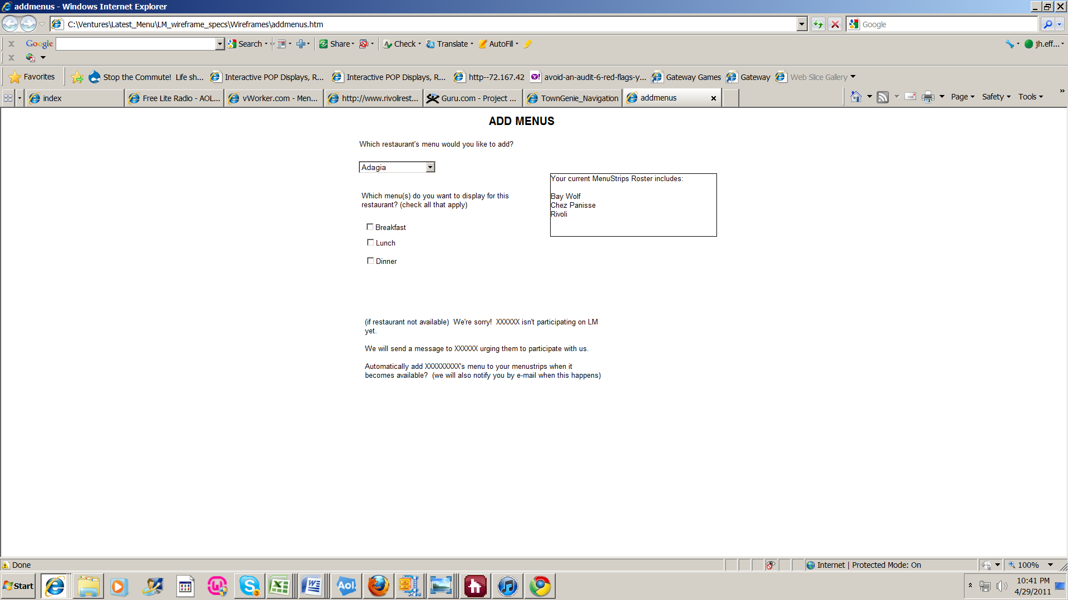

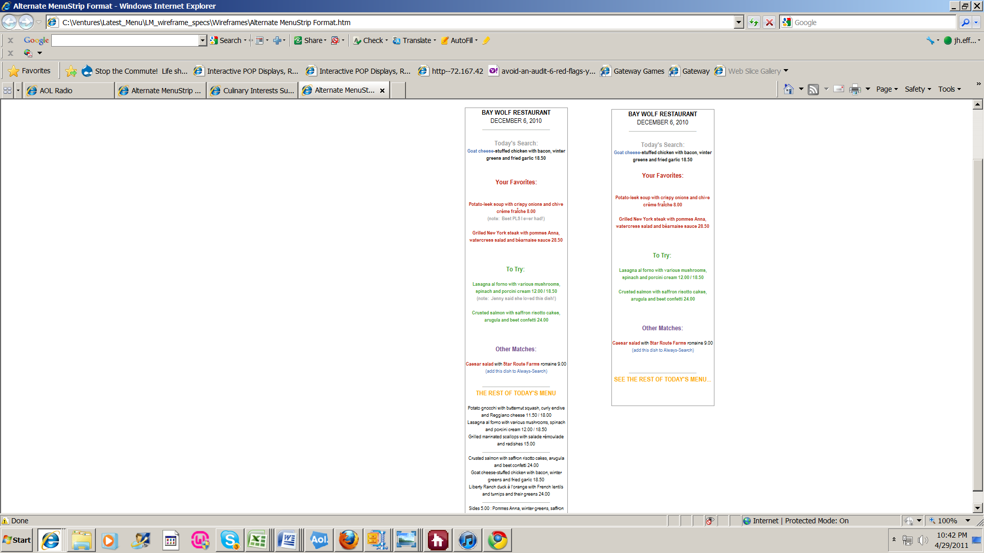

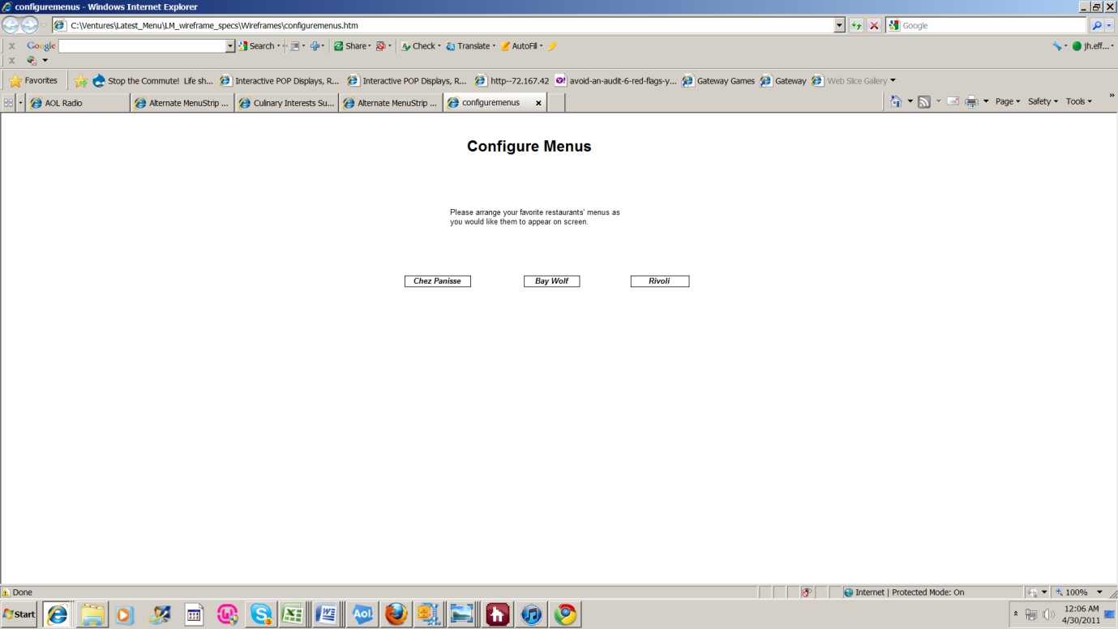

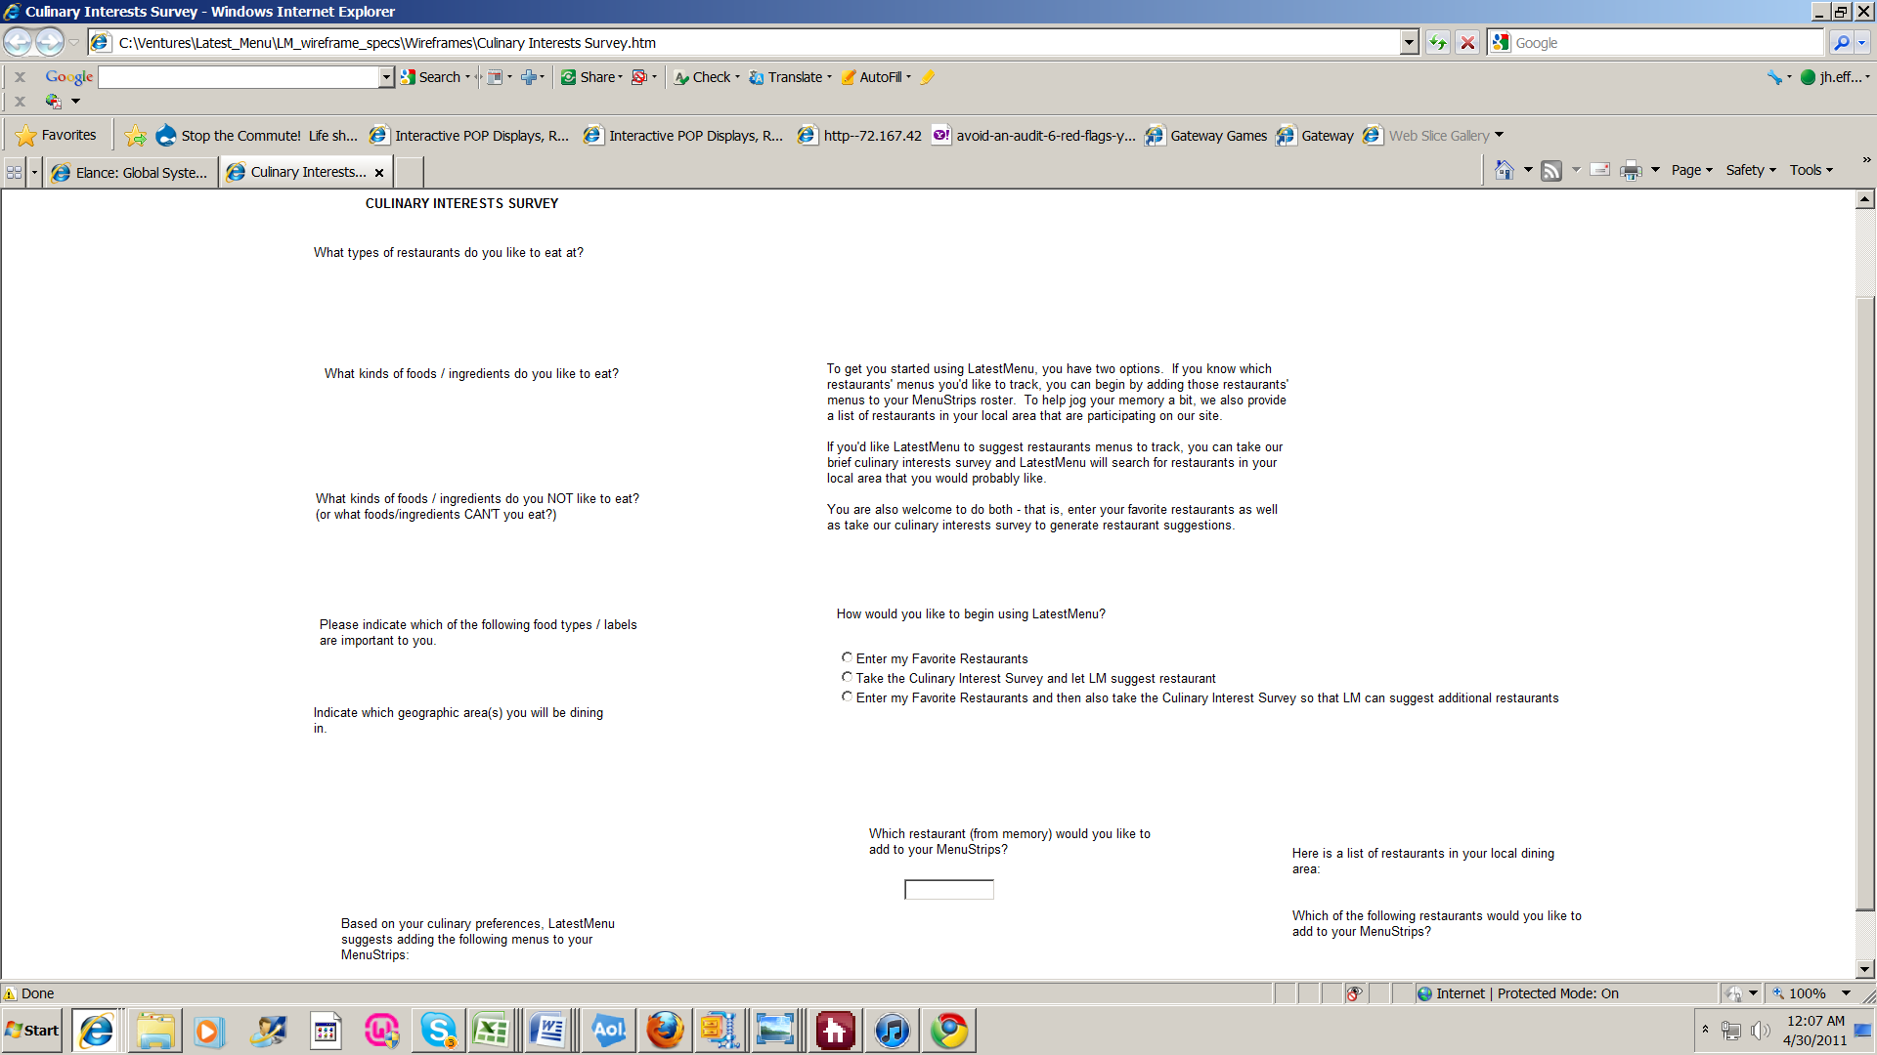

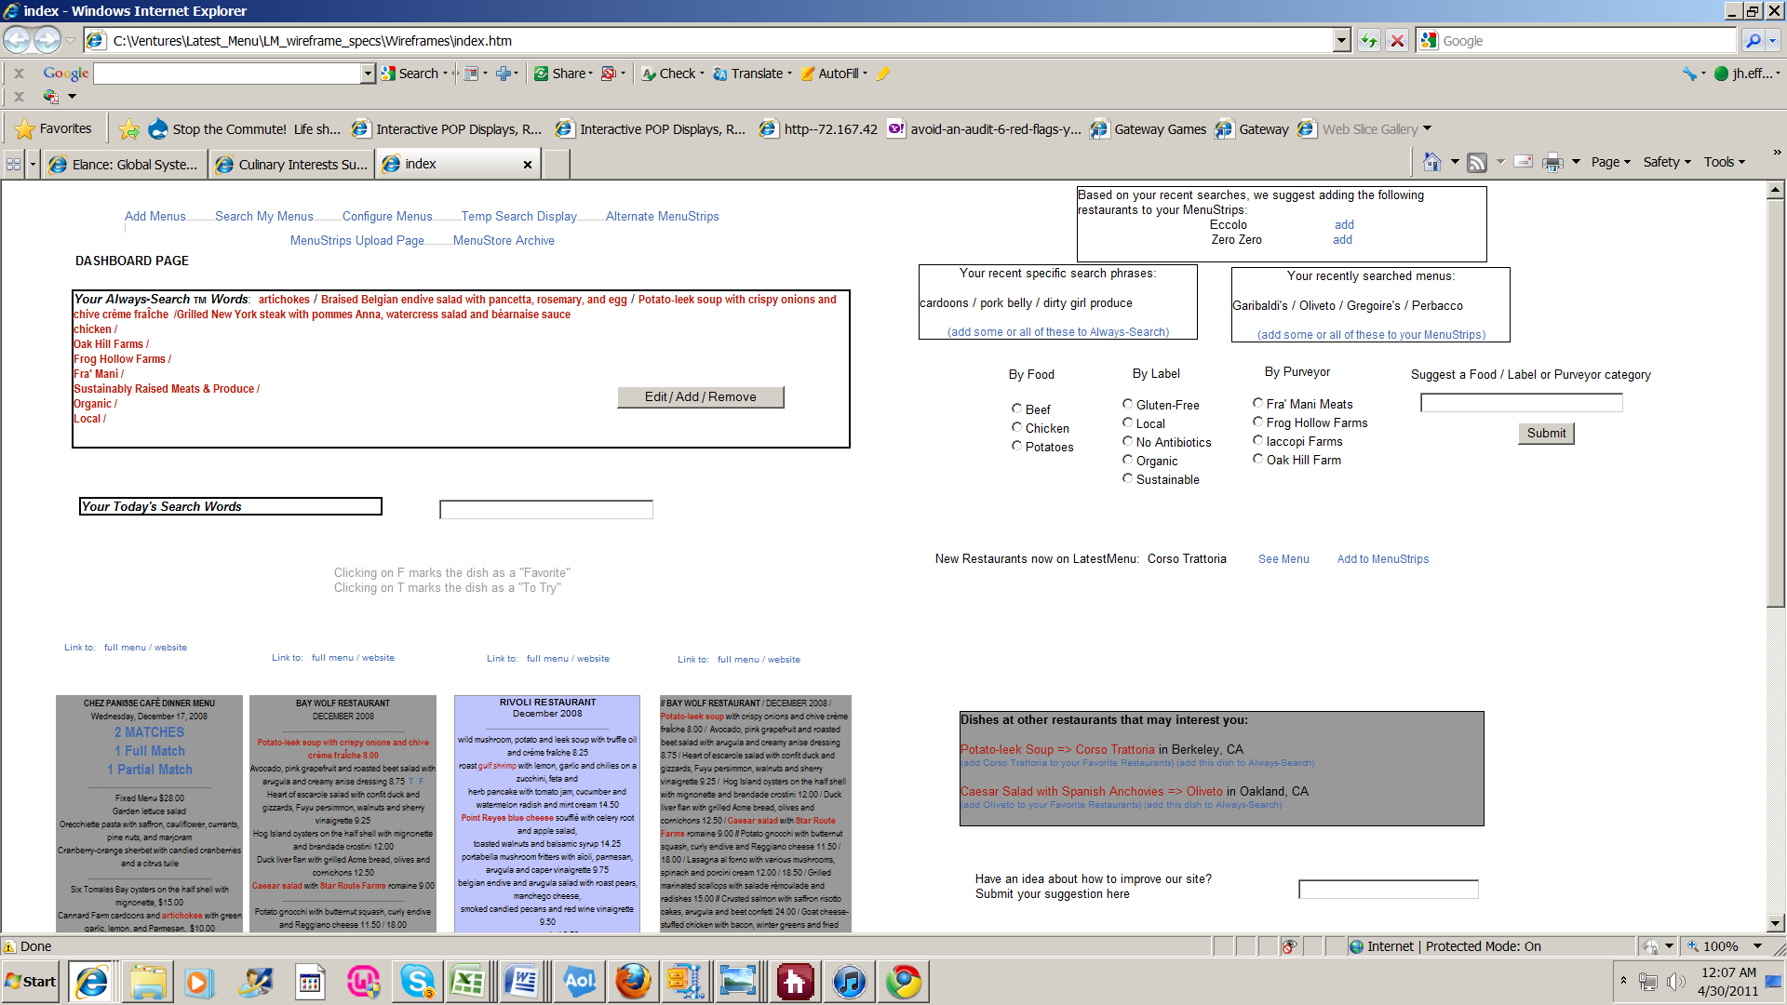

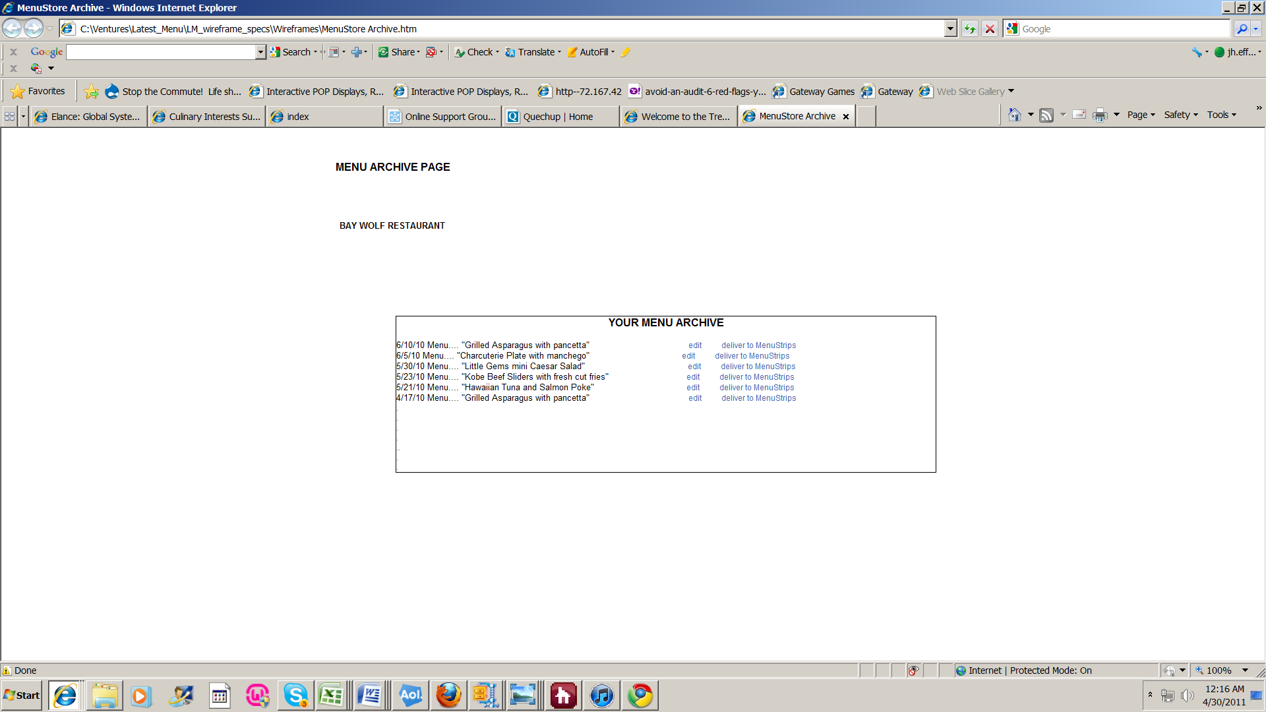

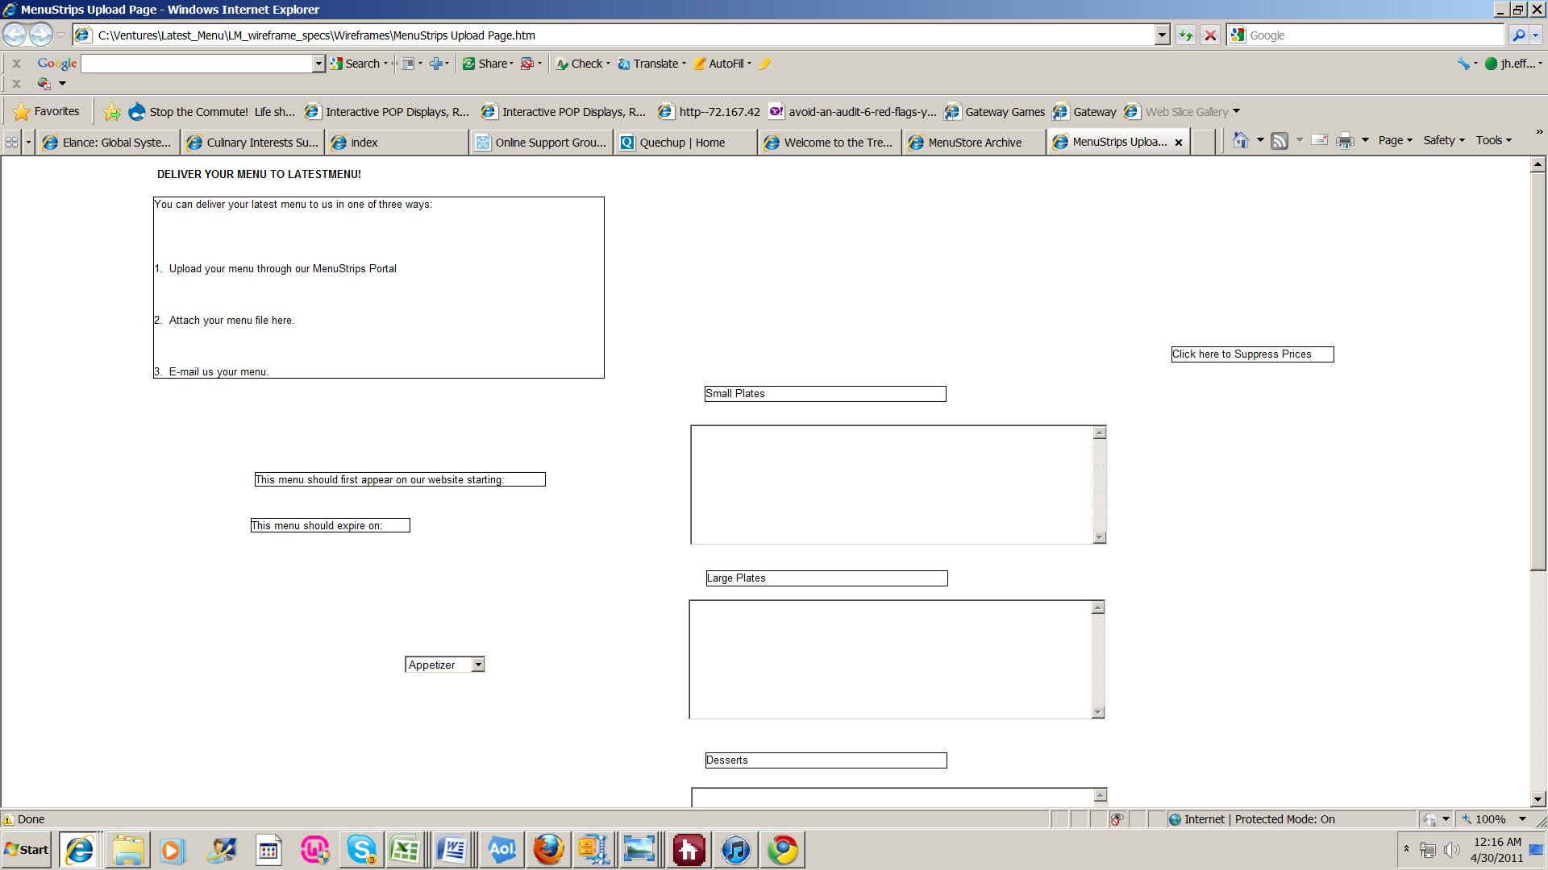

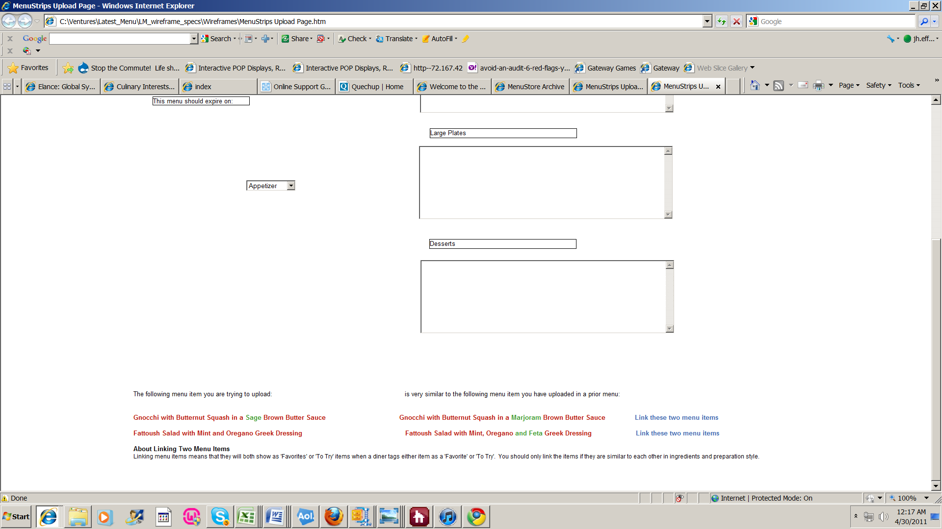

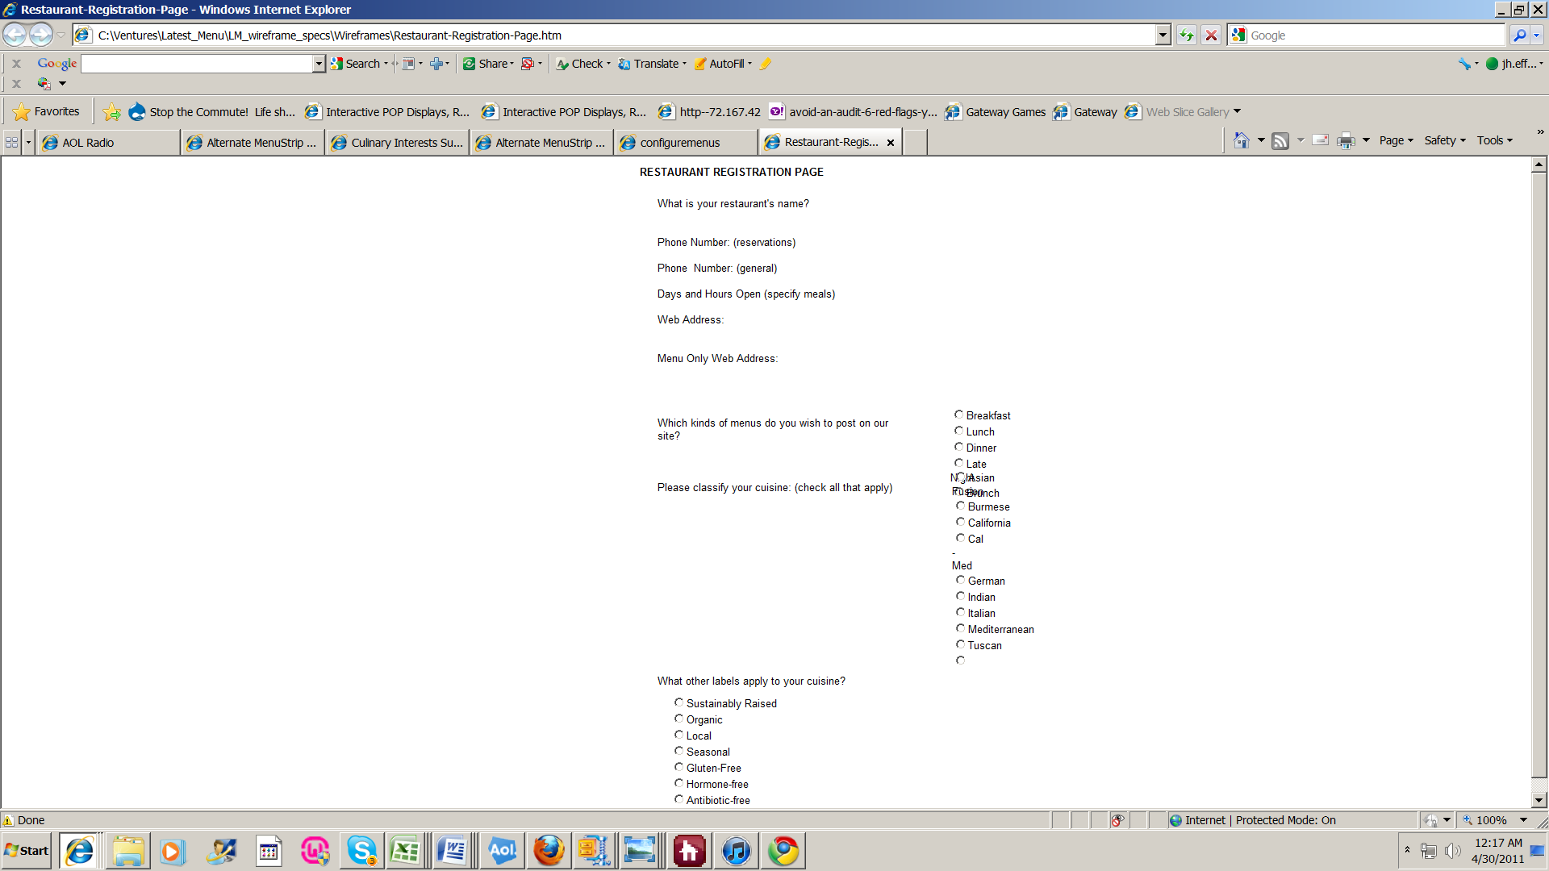

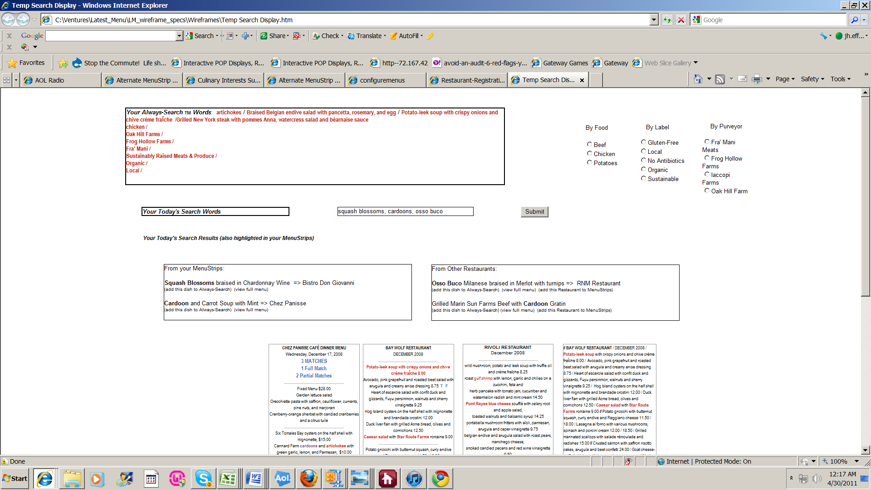

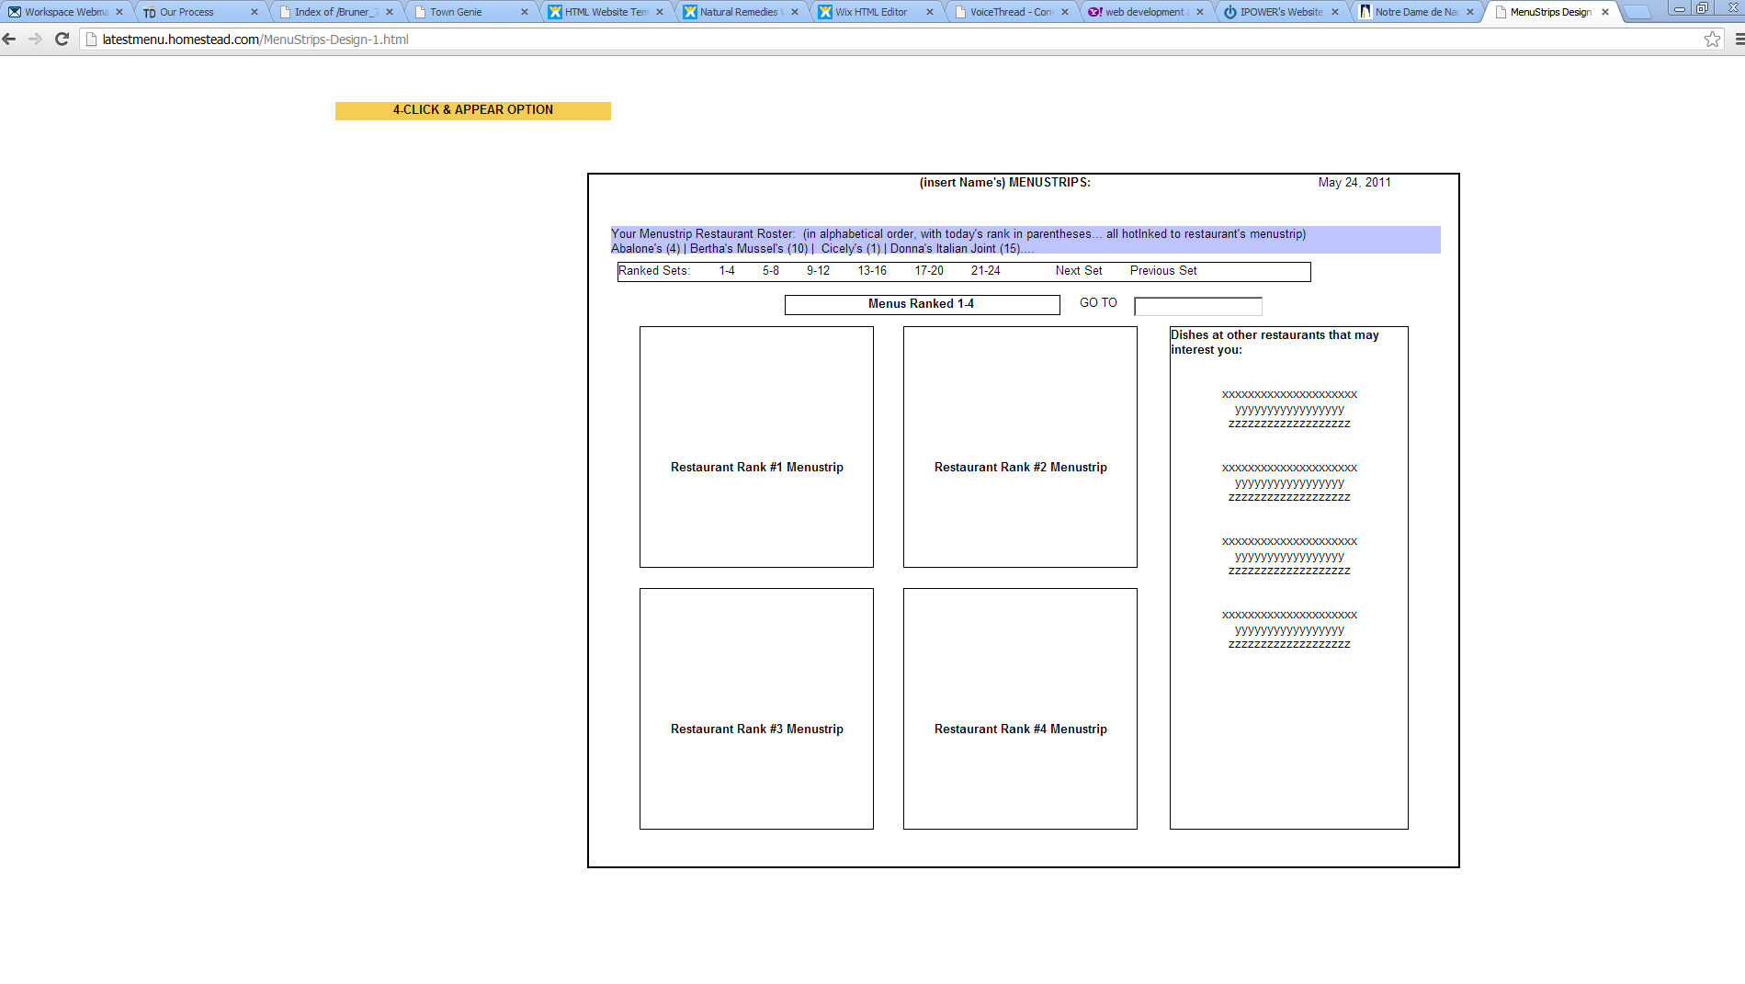

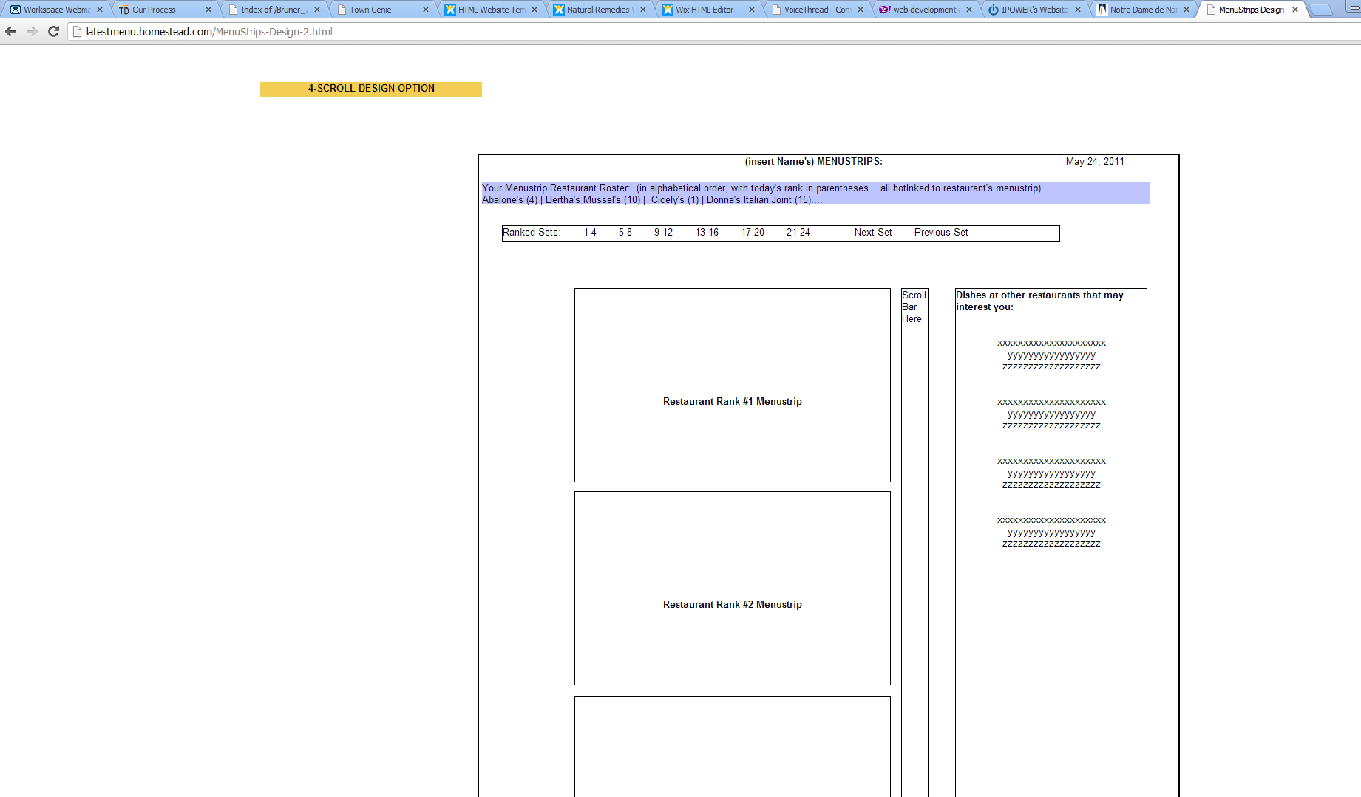

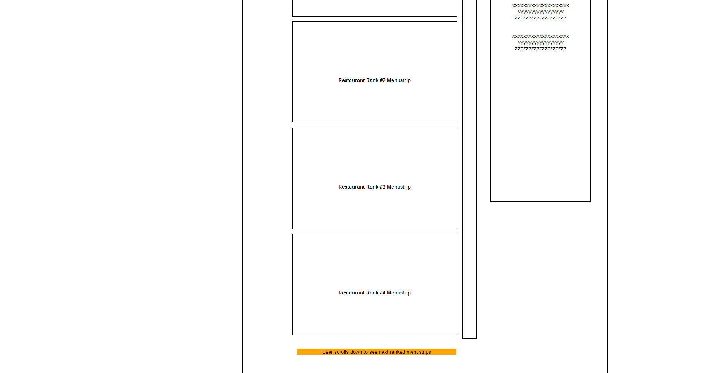

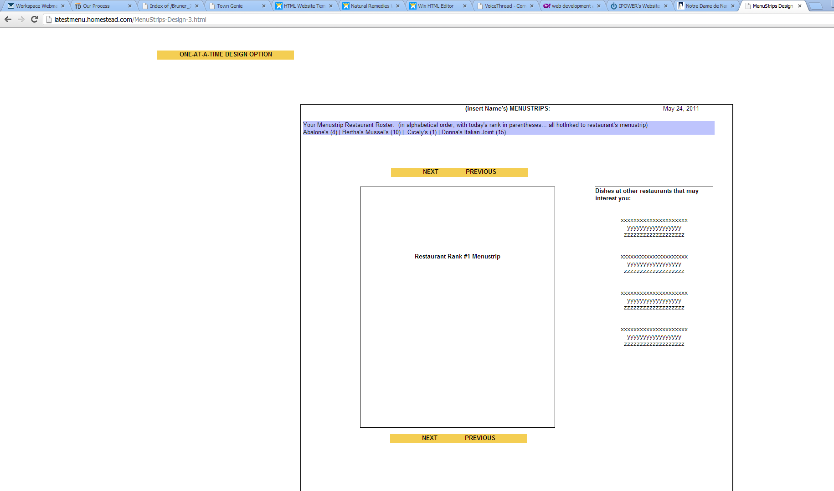

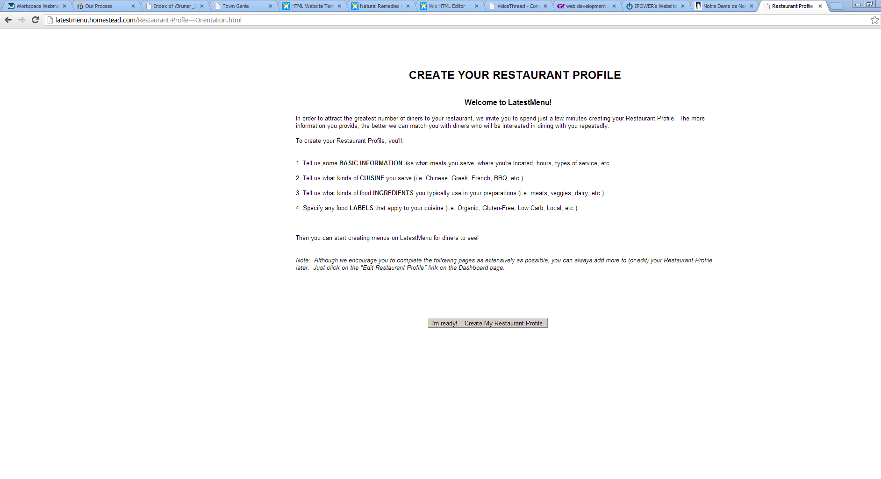

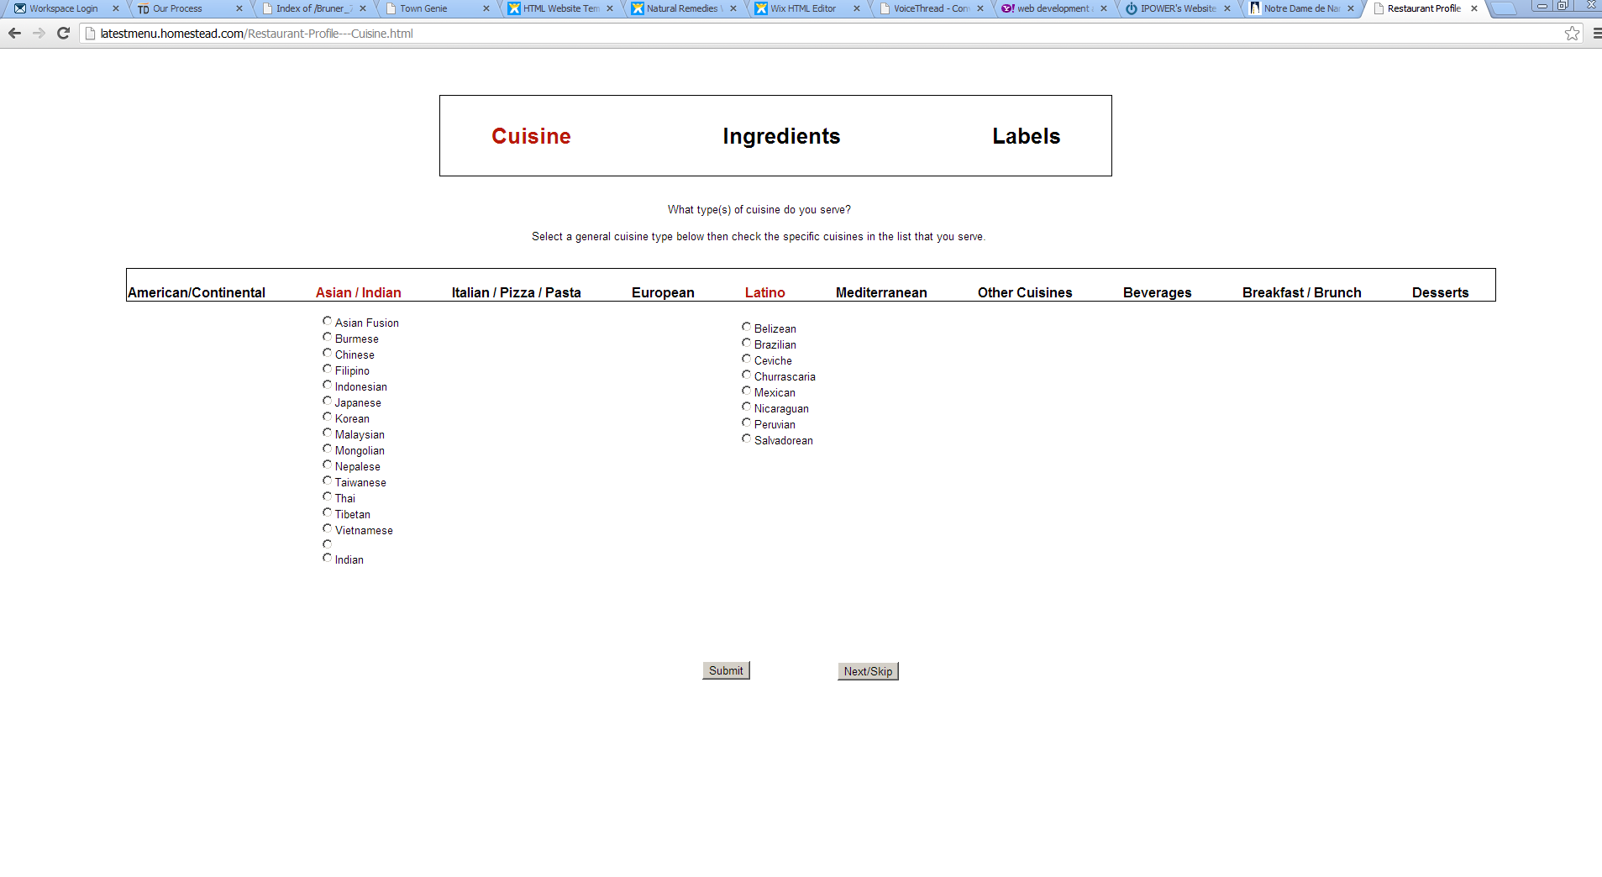

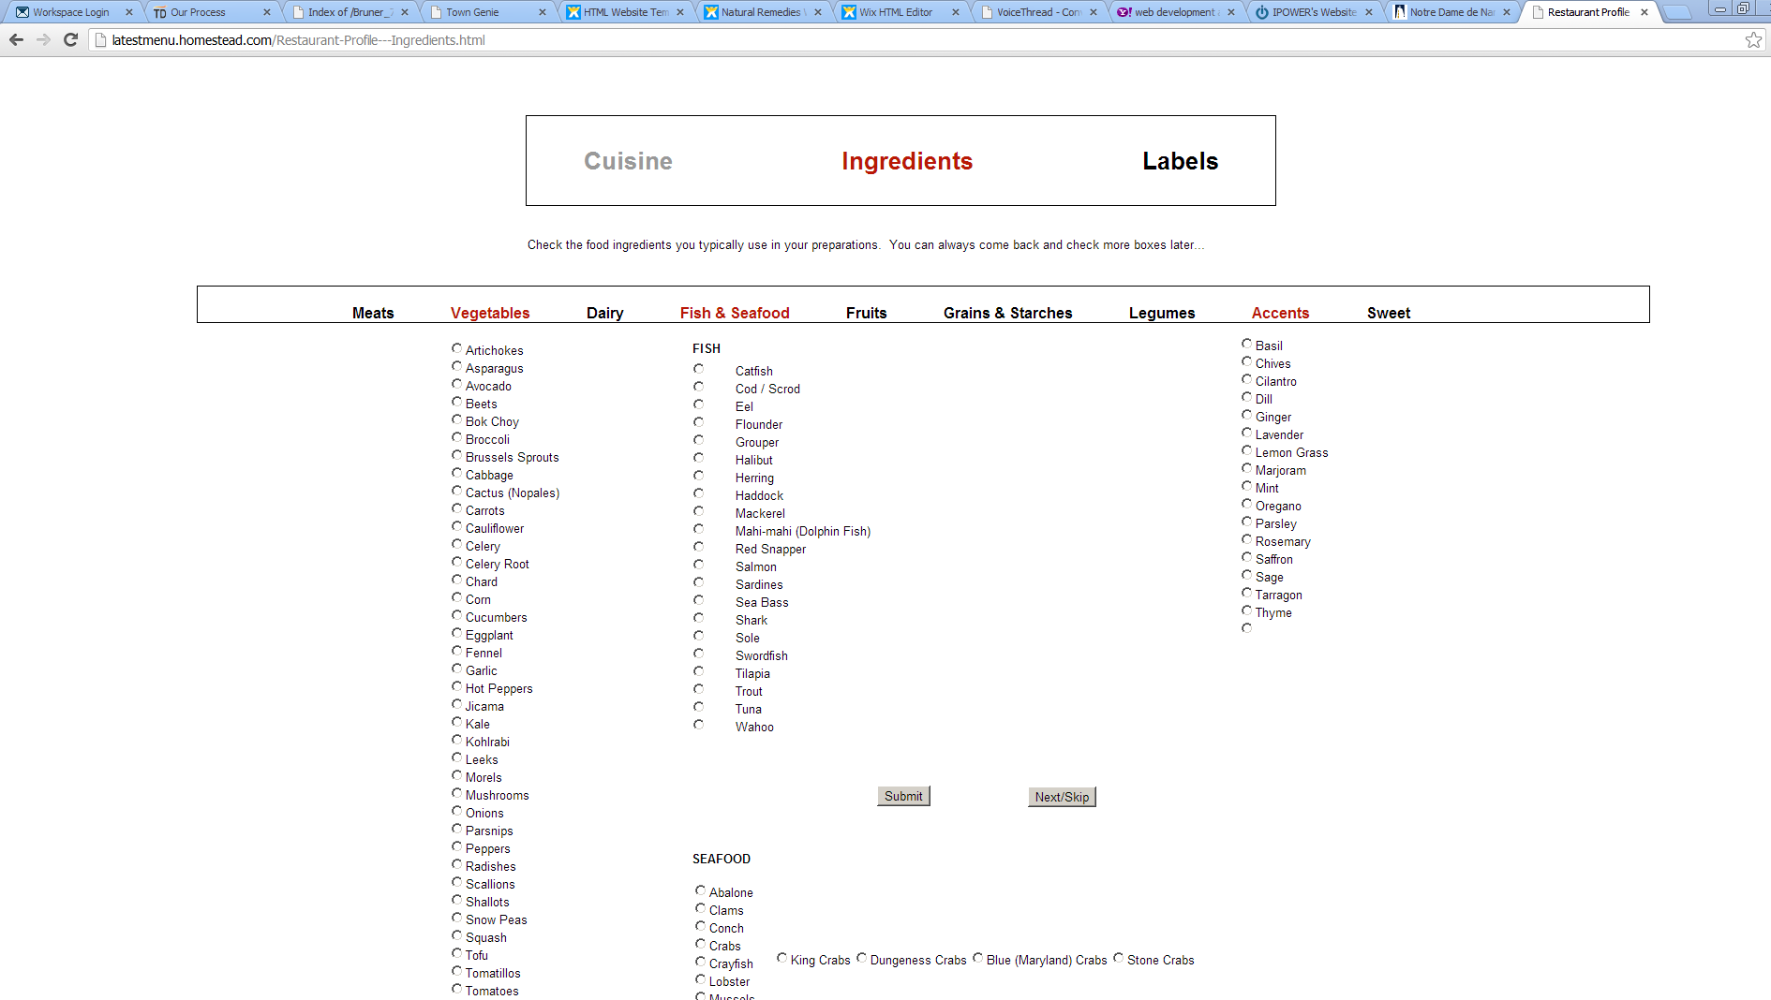

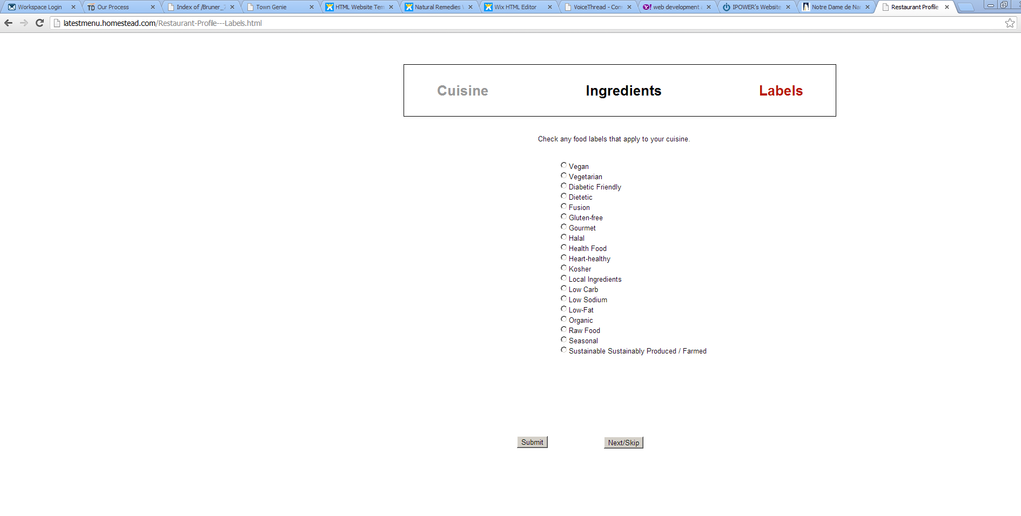

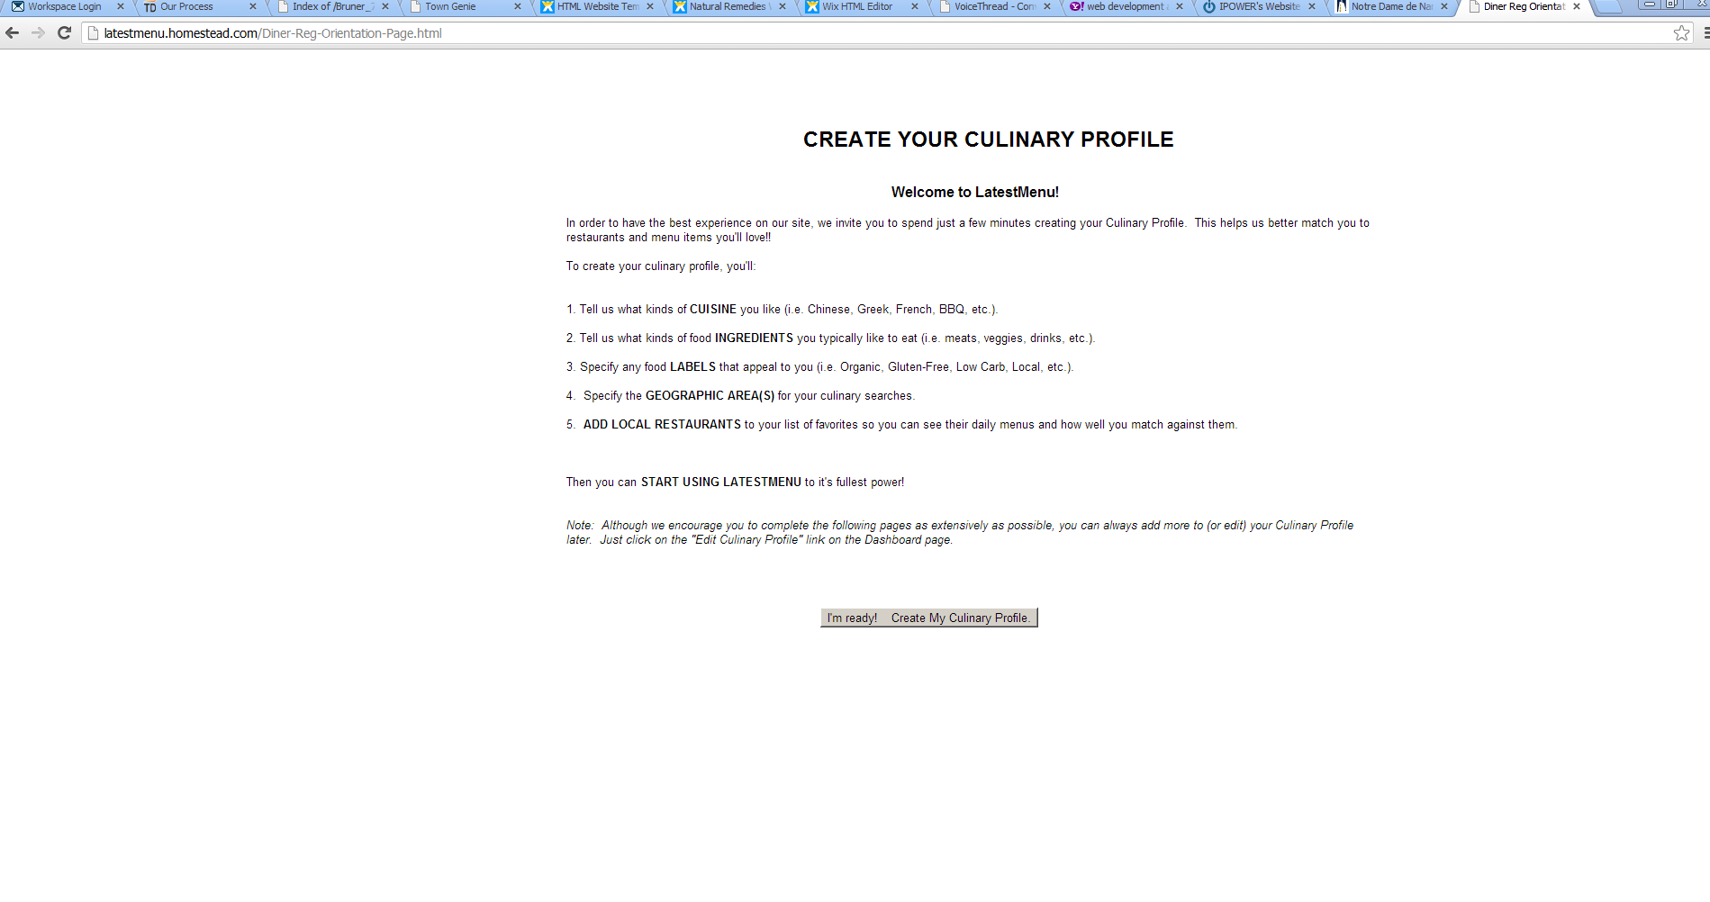

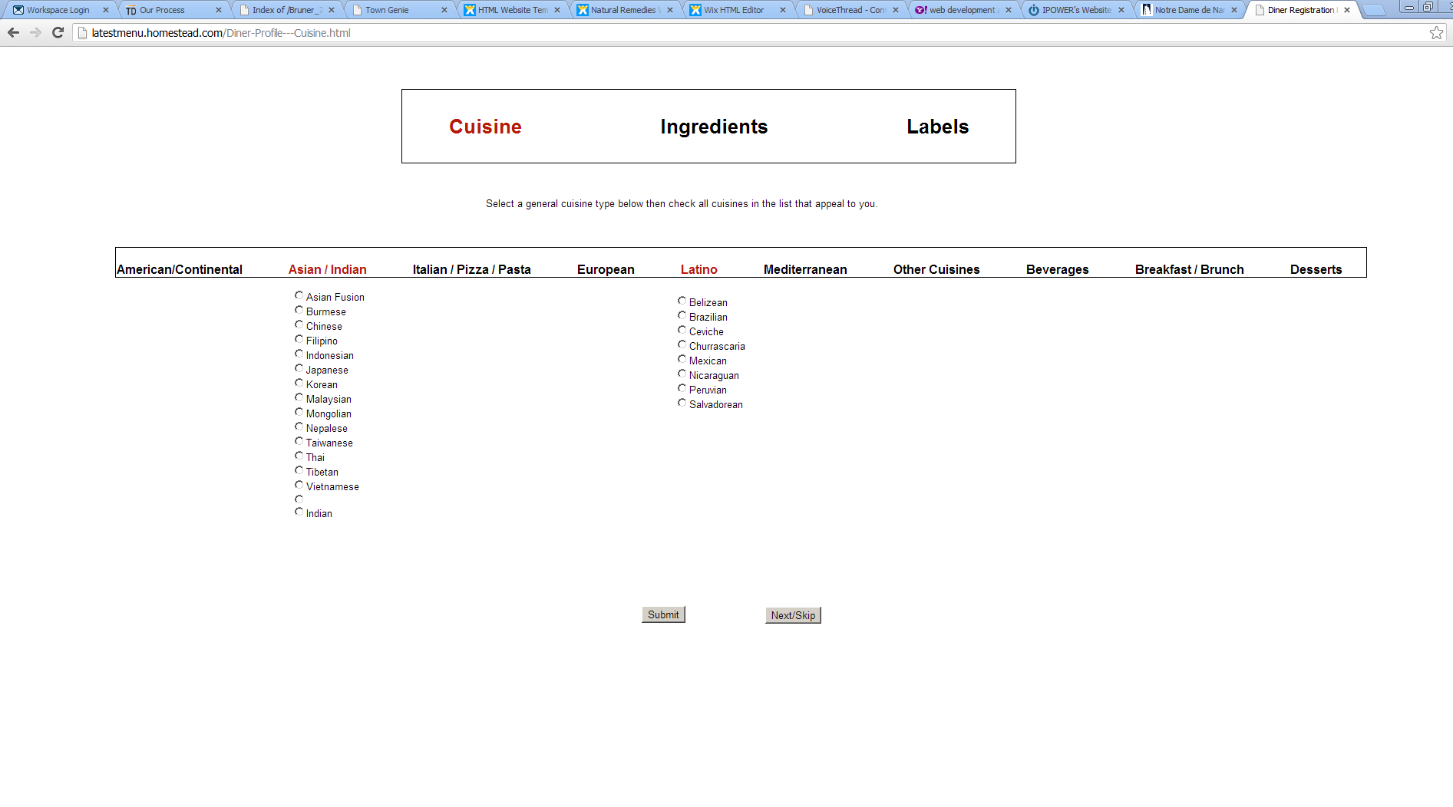

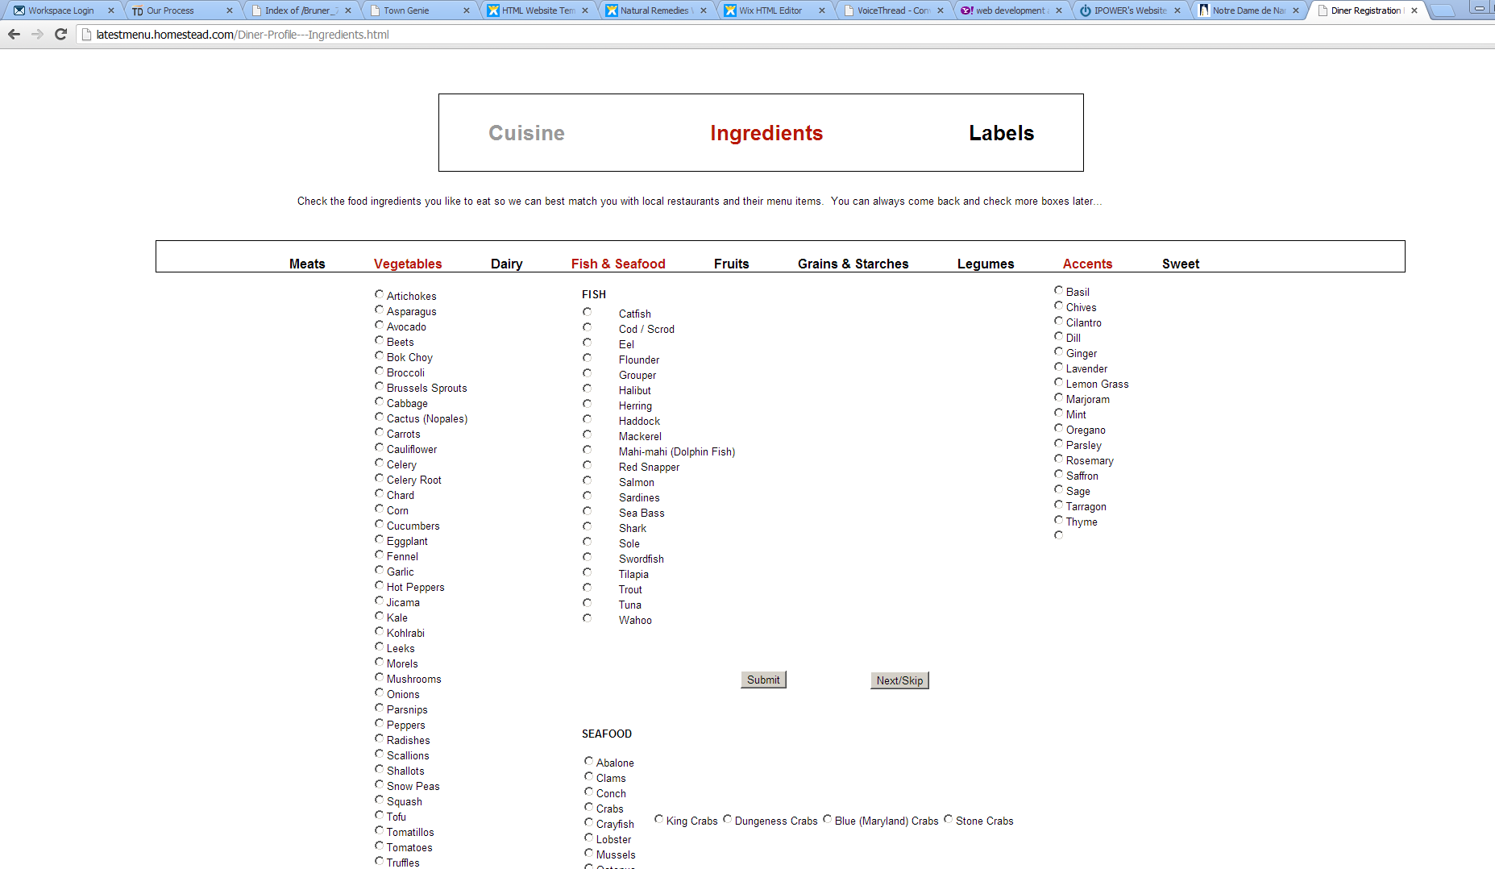

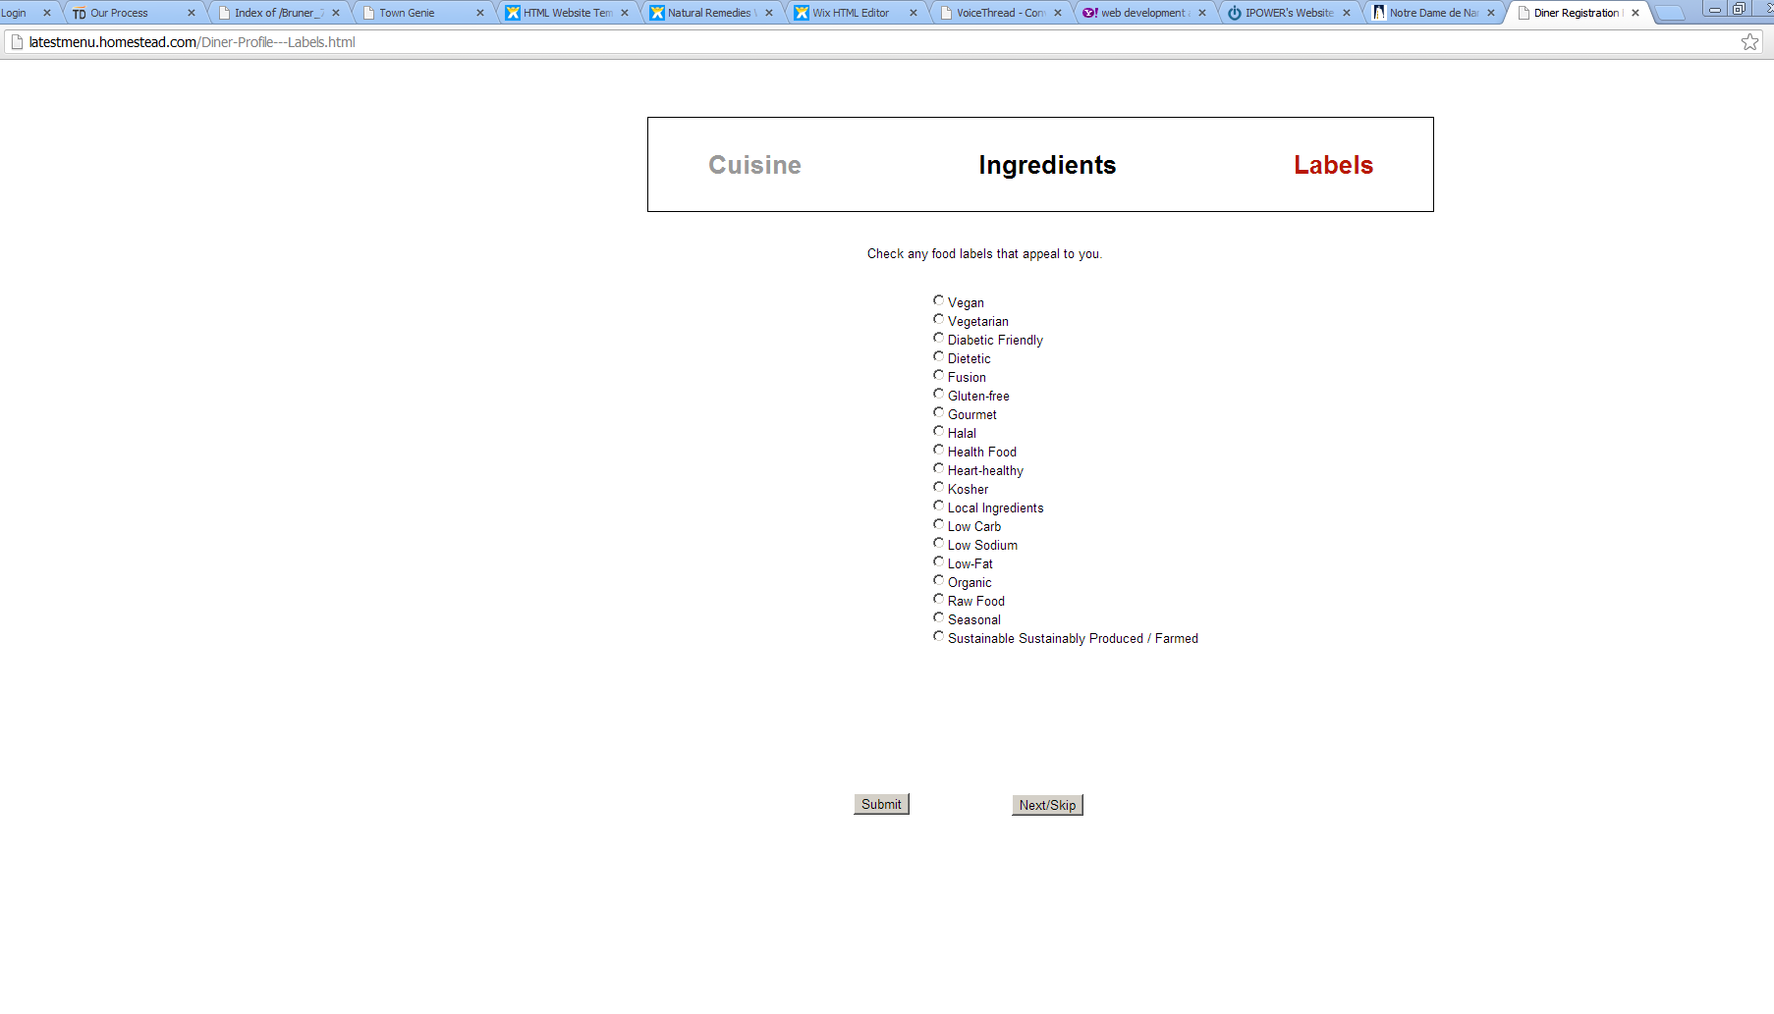

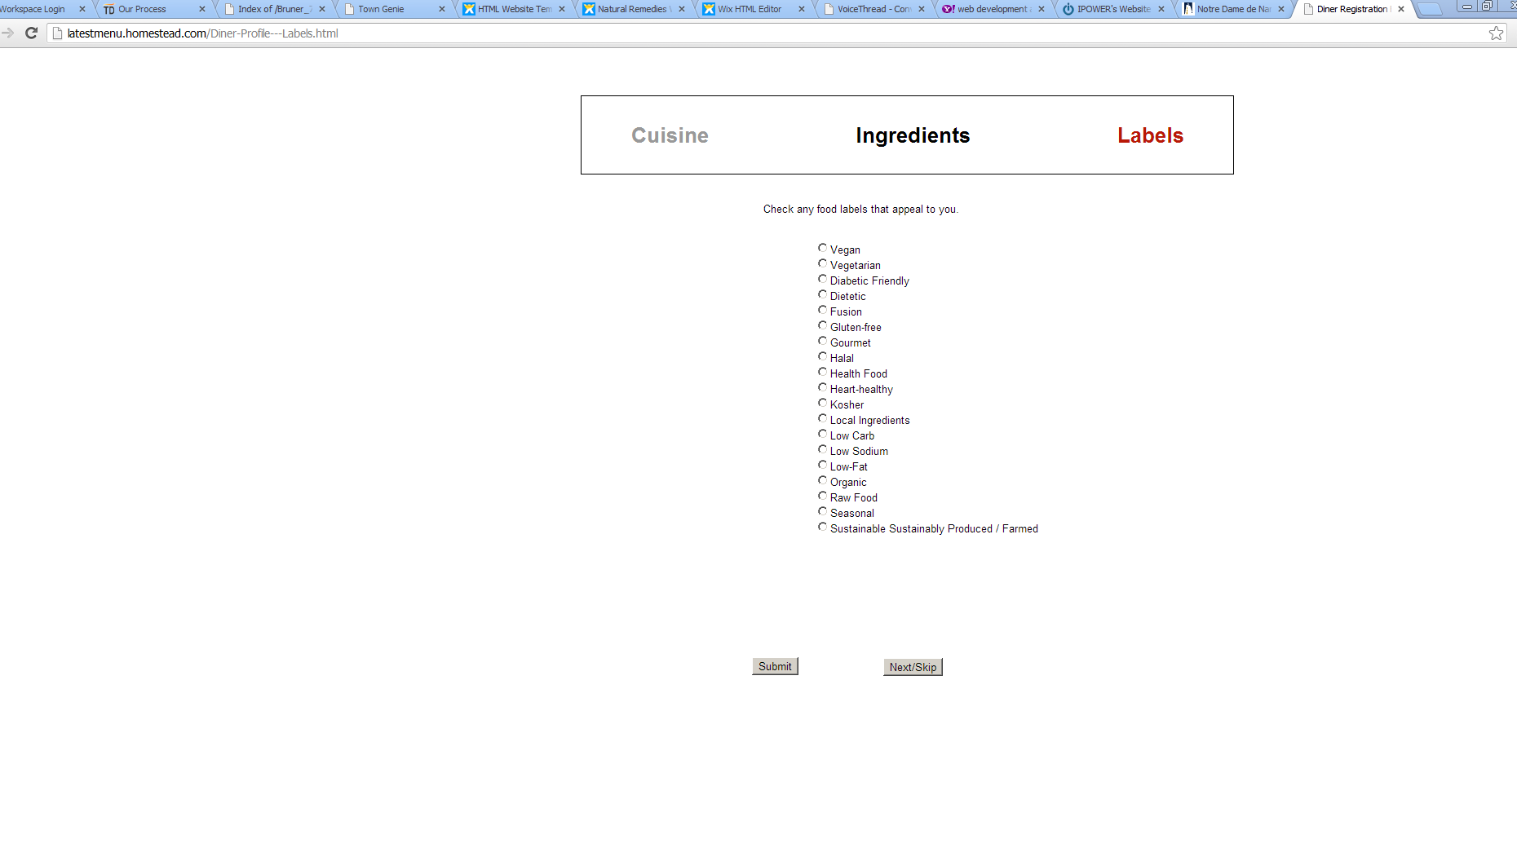

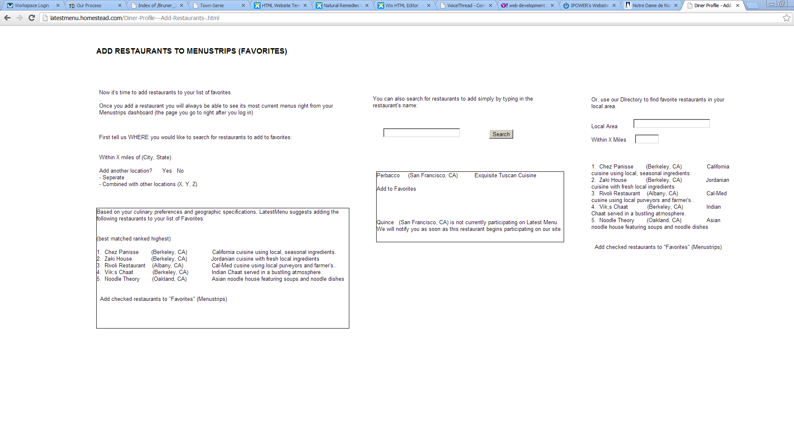

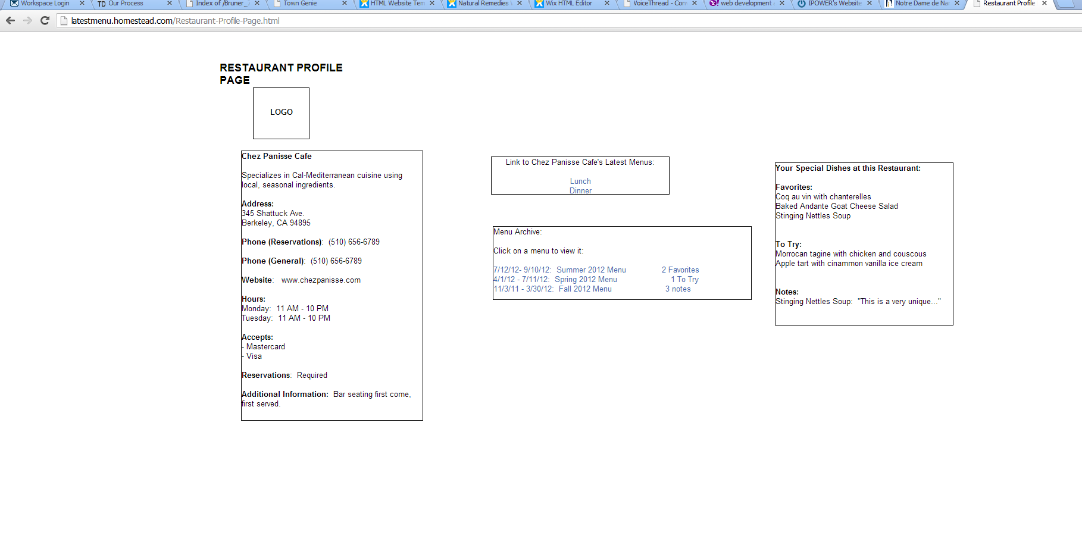

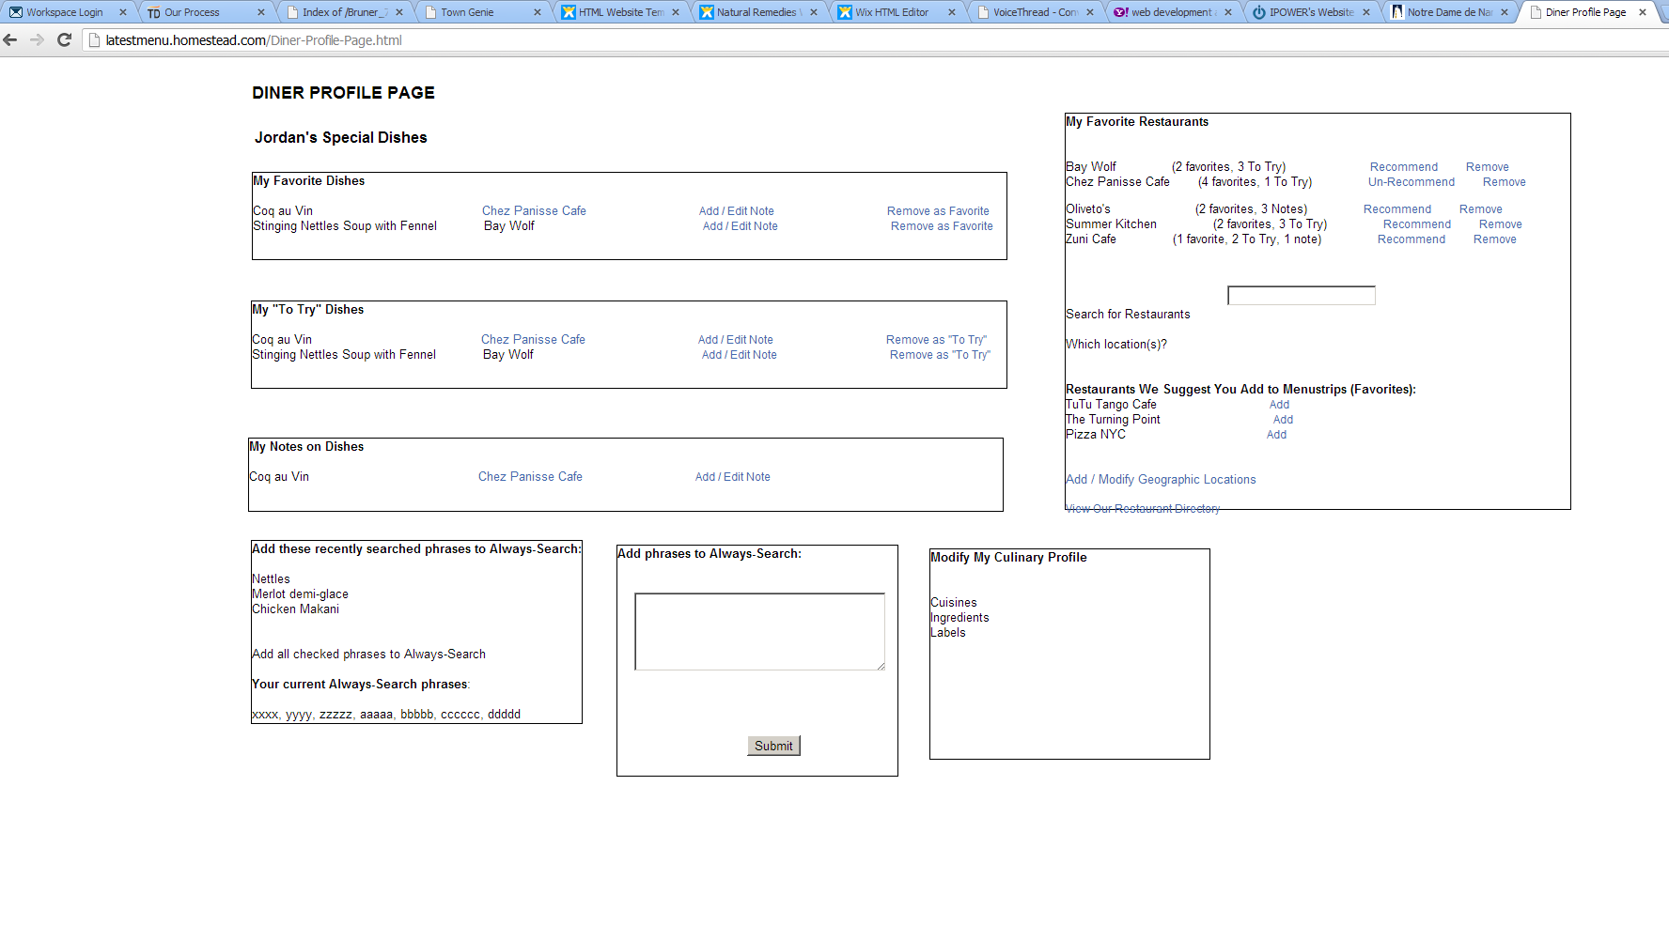

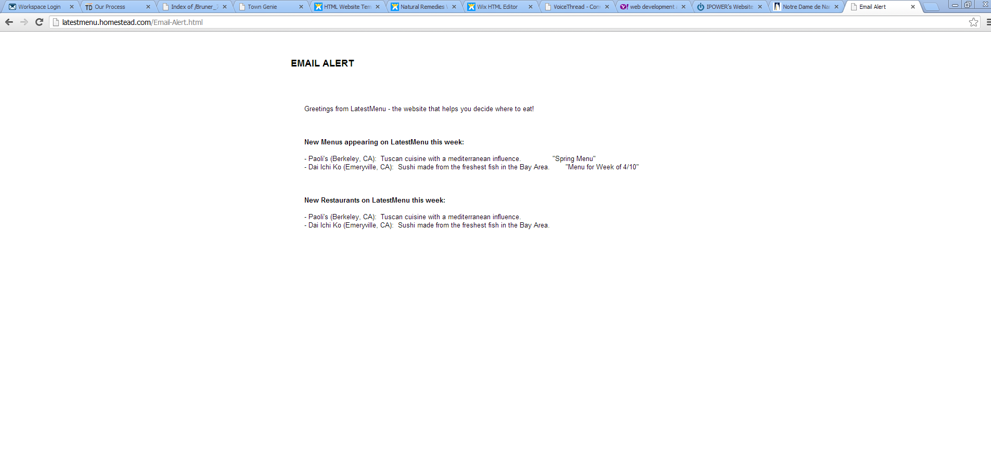

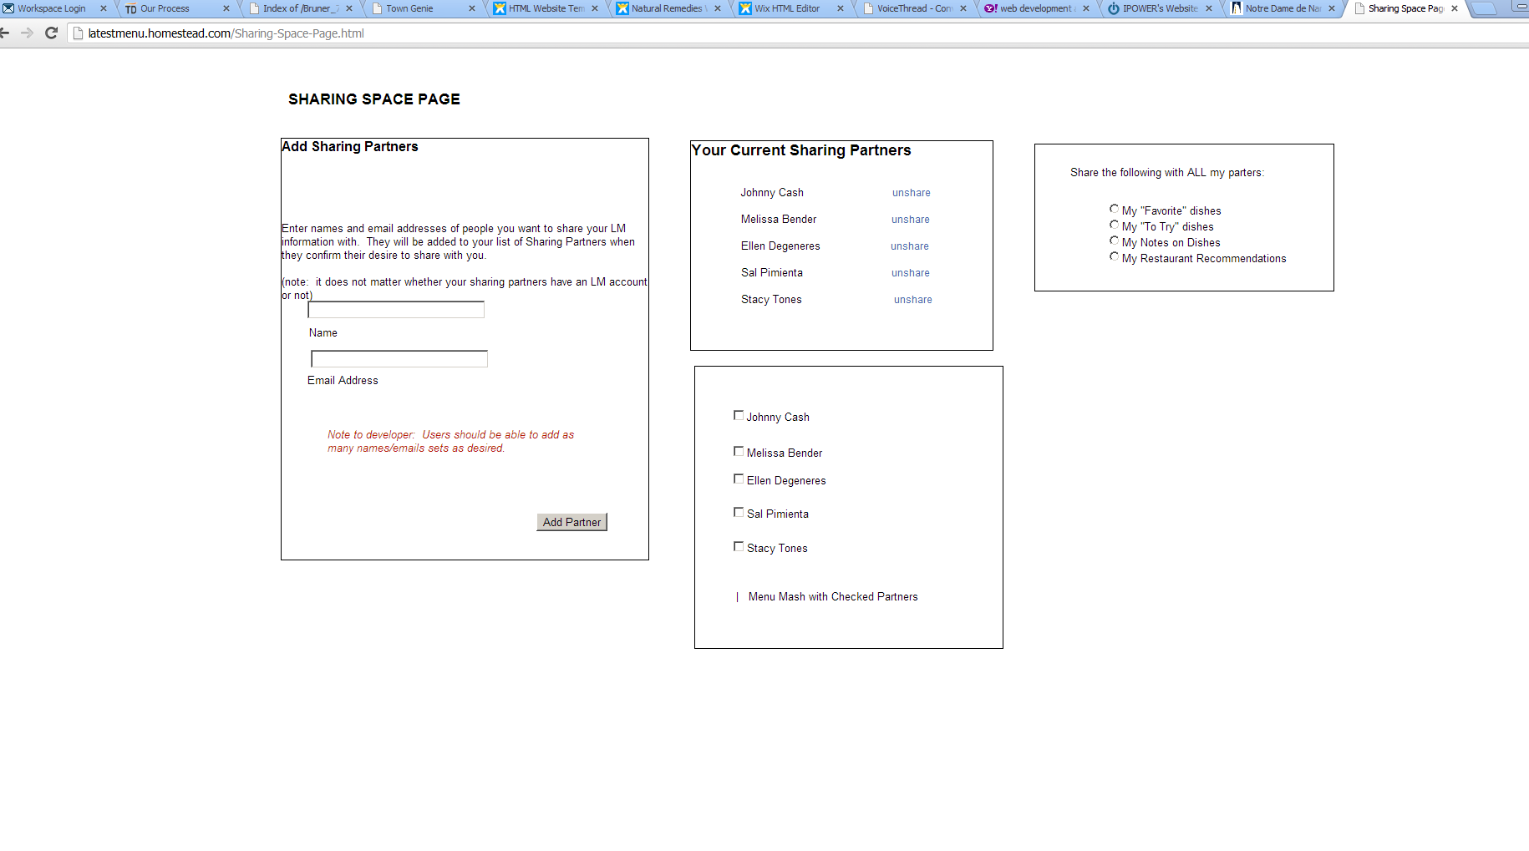

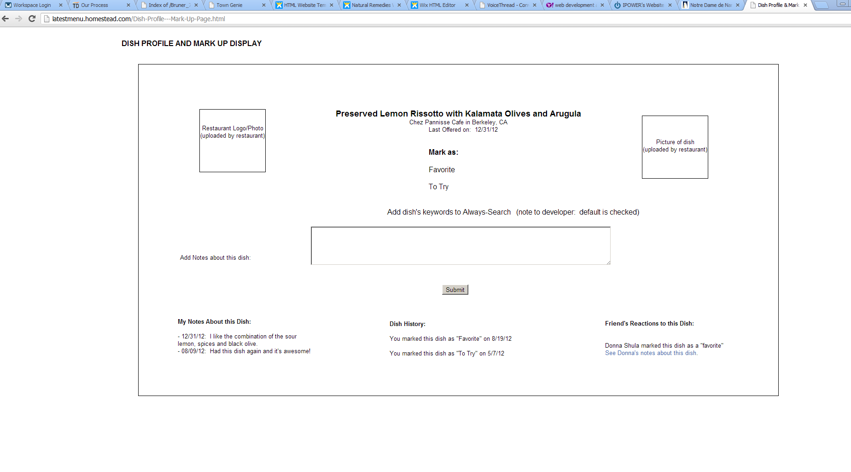

1. **UI MOCKUPS**

Trino Web Solutions and Trevortin will using the following User Interface mockup as a starting point for developing the dashboard page (and related pages) with the understanding that the below design is an approximation and not necessarily the exact representation of how the final pages will look or function.

SAMPLE DASHBOARD PAGE

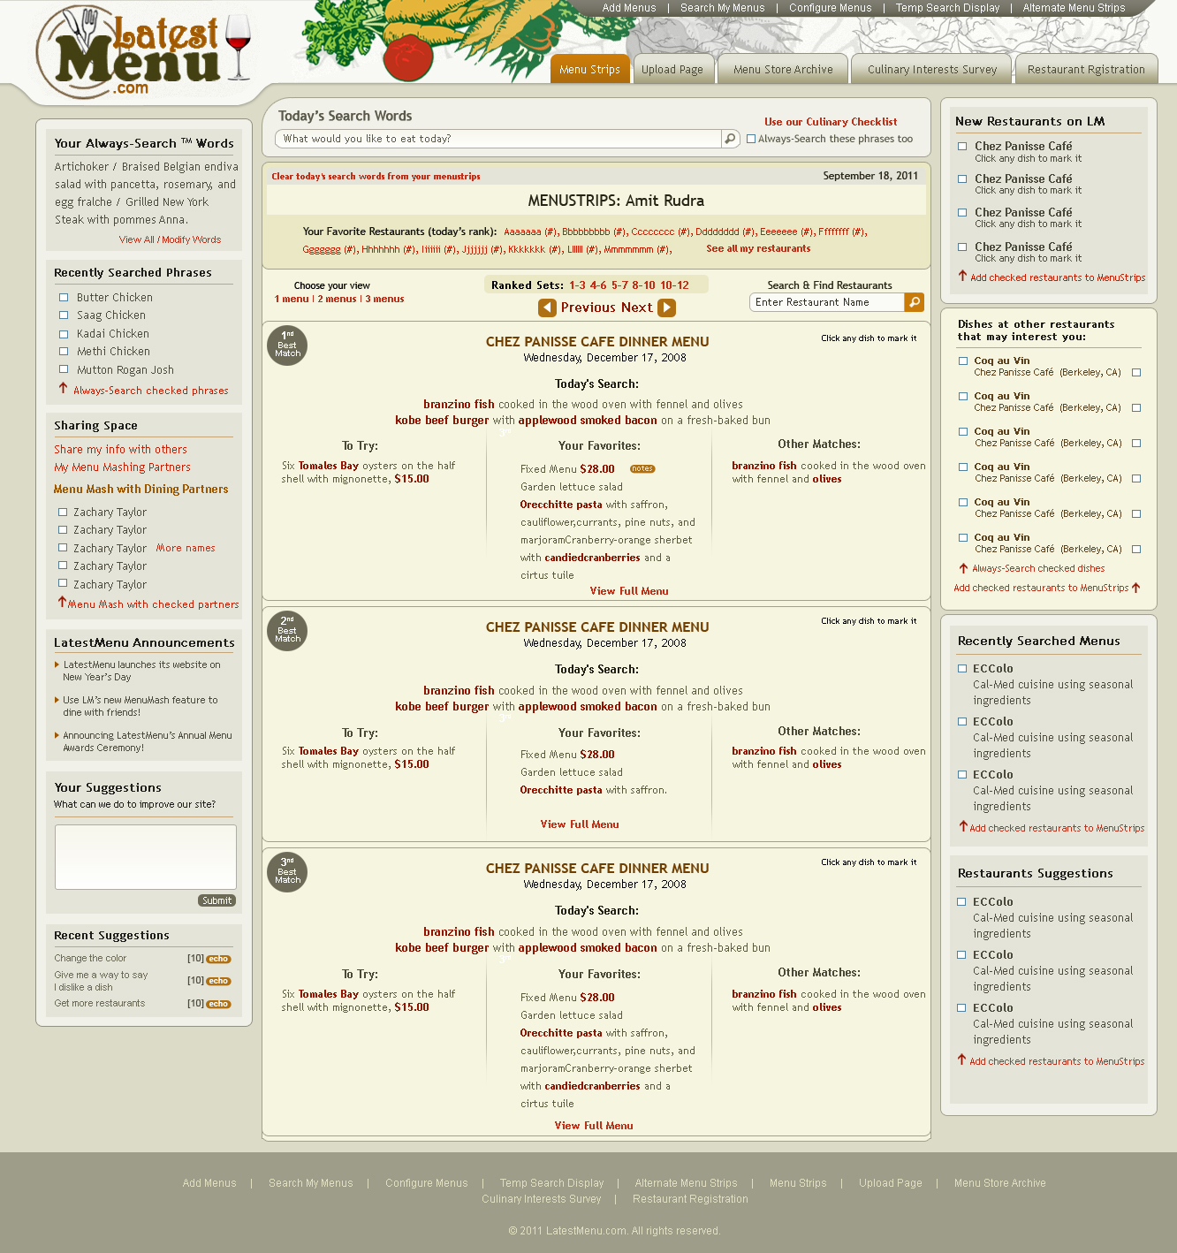

SAMPLE CULINARY PROFILE ENTRY PAGE

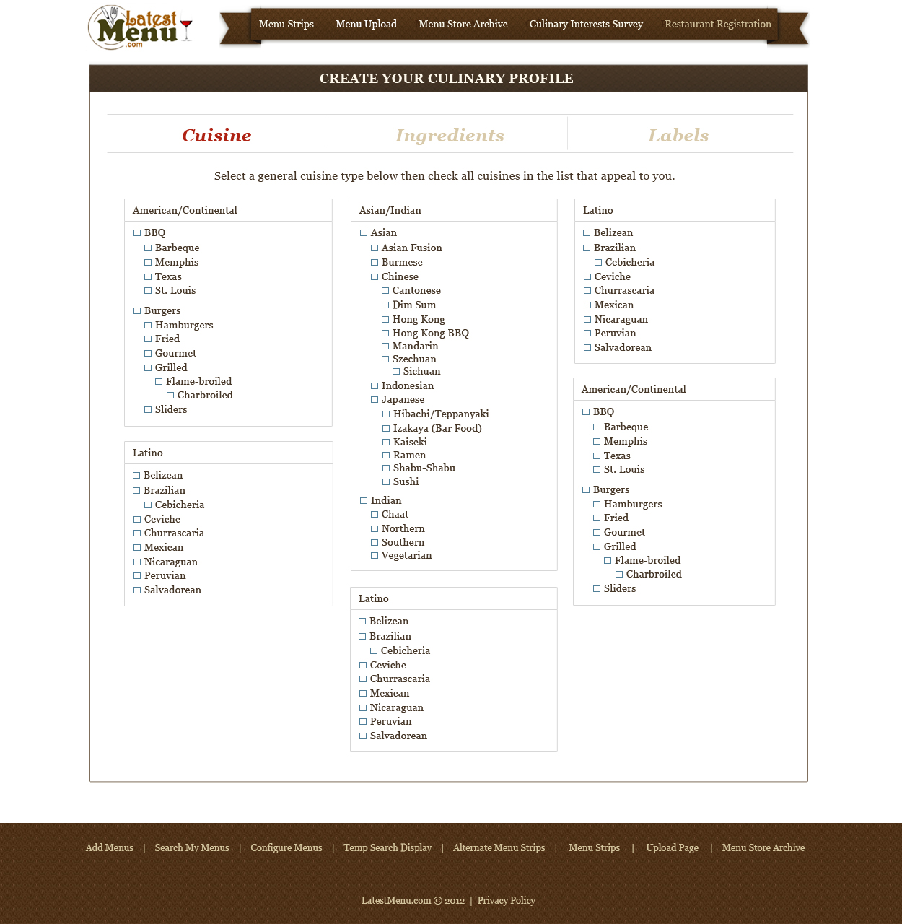

SAMPLE MENU CREATION INTERFACE PAGE

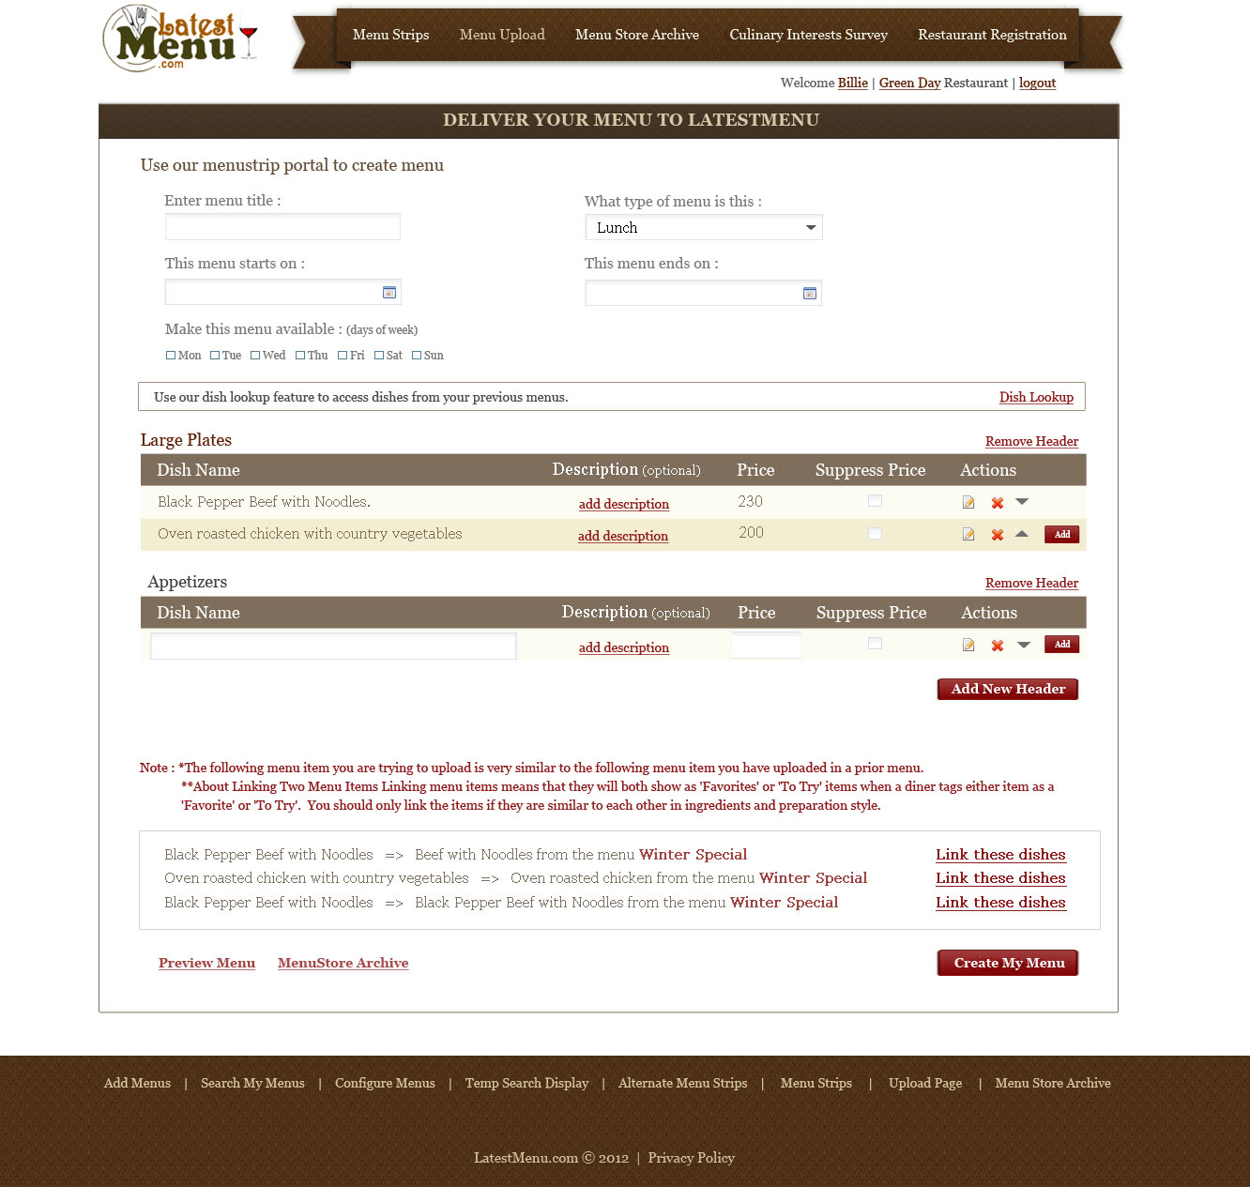

SAMPLE CULINARY PROFILE ENTRY PAGE



SAMPLE MENU CREATION INTERFACE PAGE



SAMPLE MENU PREVIEW PAGE

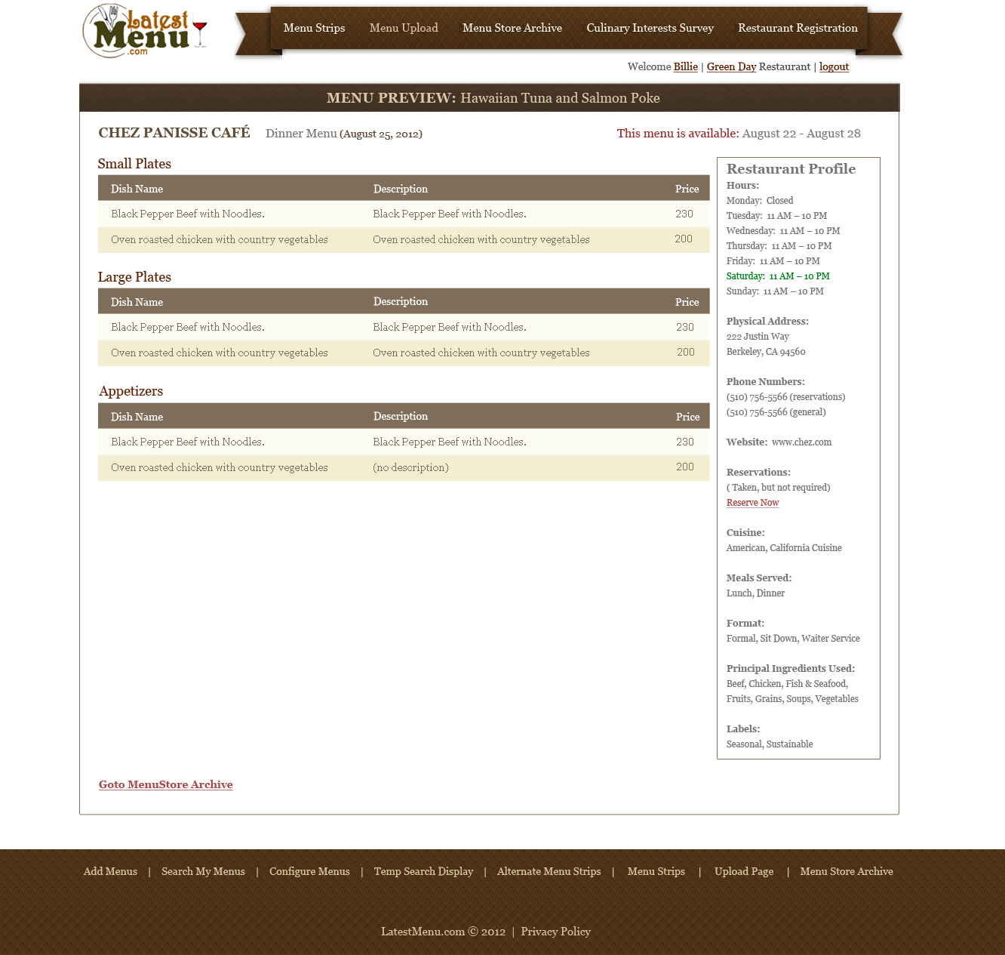

SAMPLE HOURS OPEN FORM IN RESTAURANT REGISTRATION

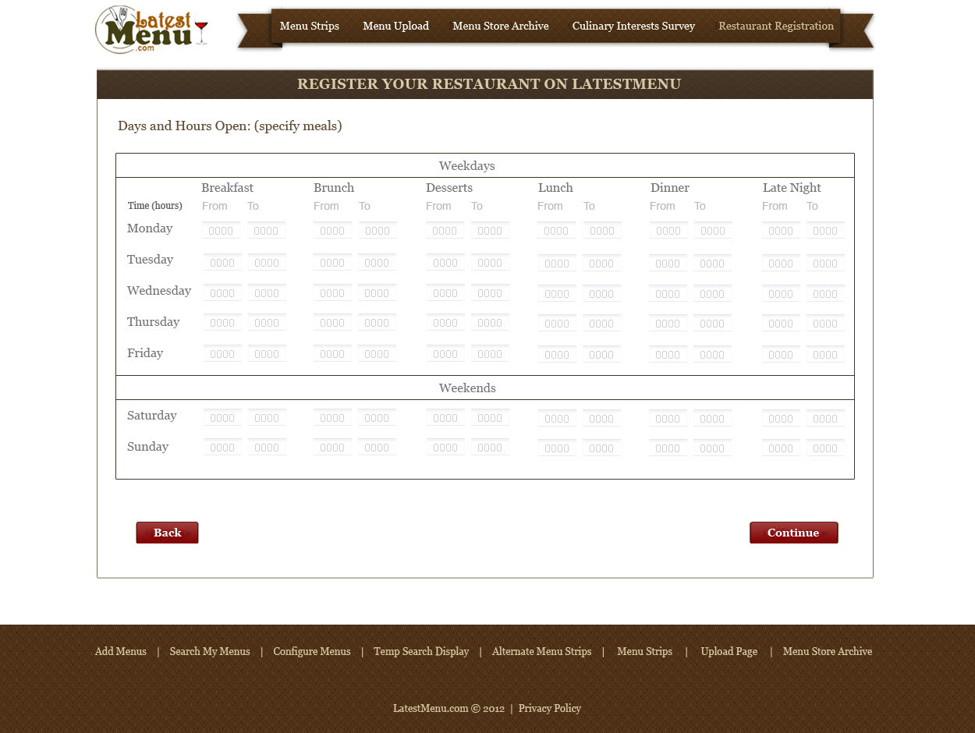

SAMPLE INFORMATION FORM FOR RESTAURANTS IN REGISTRATION MODULE

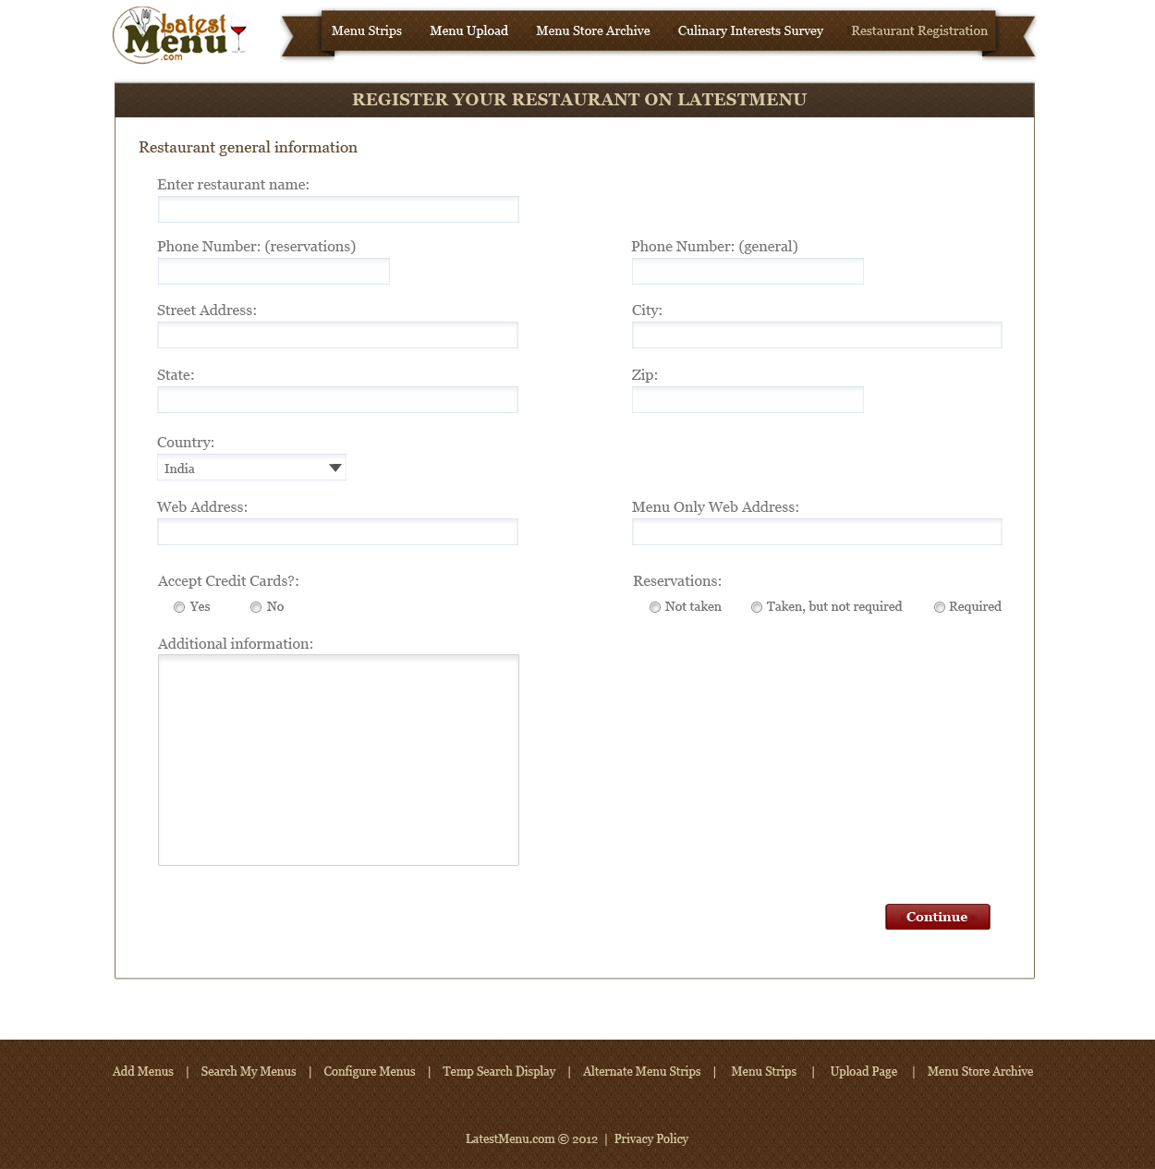

SAMPLE DASHBOARD

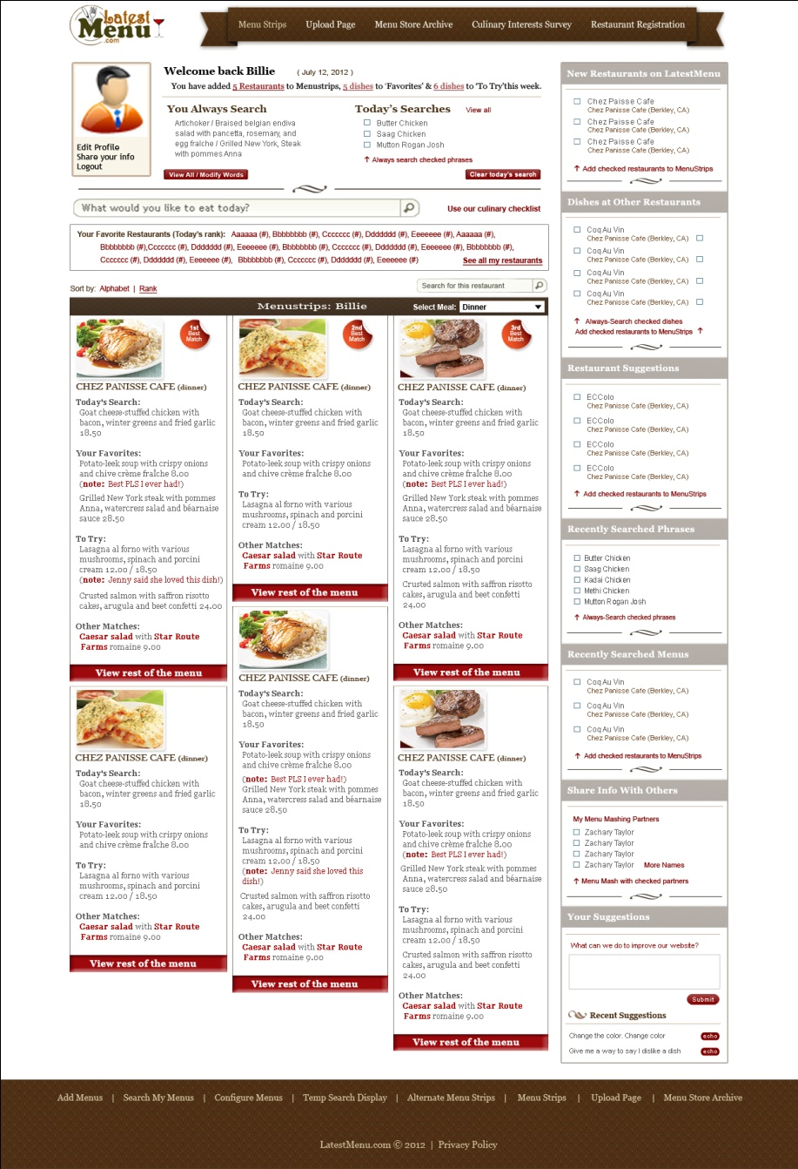

SAMPLE DASHBOARD

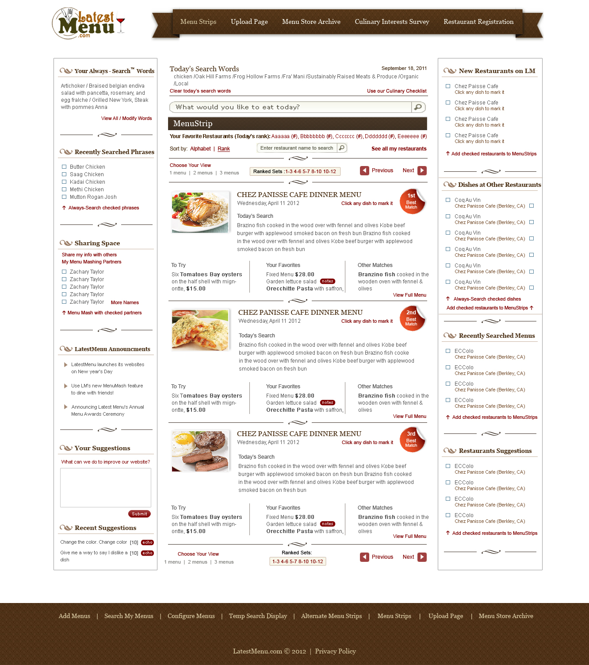

SAMPLE DASHBOARD

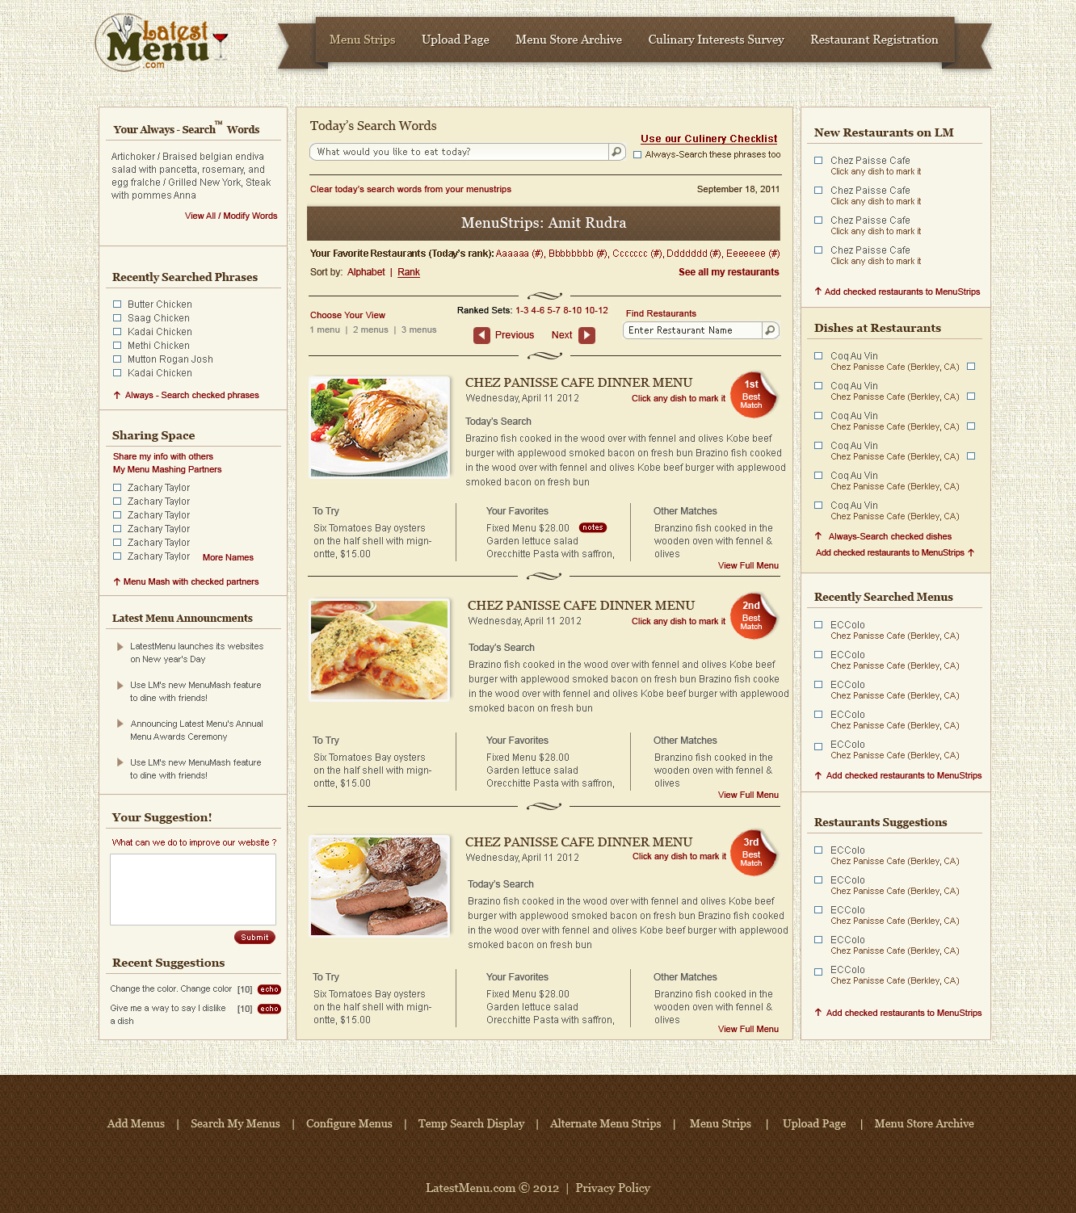

MENU PREVIEW (ONE VERSION):

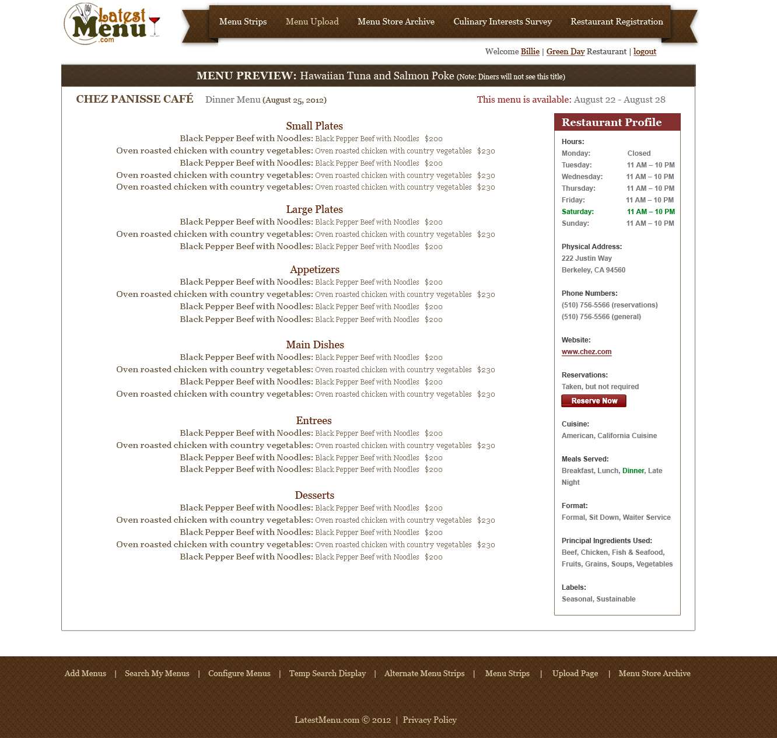

1. **WORK BREAKDOWN STRUCTURE & PAYMENT PLAN**

|  |  |  |  |
| --- | --- | --- | --- |
| **Milestone** | **Tasks (elaborated below)** | **Payout** | **Delivery Date** |
| 1 | layout design look and feel will be provided via PSD before delivery date, once approved it will be chopped into HTML5 layout. All conceivable user interface pages will be coded in html.  -logo design | Please fill in | Please fill in |
| 2 | -restaurant registration, account settings and preferences - profile edit/update/delete, menu archive system  -menu delivery options - upload/edit/delete  -diner registration, account settings and preferences with profile edit/update/delete | Please fill in | Please fill in |
| 3 | all search functionalities (specific, general and passive) with matching algorithms - Perma-search, Temp-search; search for restaurants, search directories  -dashboard functionalities - menustrips, supplementals and search results  -favorites, to try, share with friends, suggestions, top ranked functionalities  -friends functionality: share info (favorite restaurants, favorite dishes, to trys, notes) with friends  -mashup functionality | Please fill in | Please fill in |
| 4 | -website admin dashboard with restaurant and menu alerts: Whenever a user creates an account or menu, the admin will receive an alert via email.  -website suggestion functionality: Suggestion Box  -misc pages (contact, FAQ, etc)  -device compatibility (responsive design)  -final wrap up - seo, email setup, social media integration, other: Basic SEO (meta tags, title description, etc). Social media integration - the ability to share all pages of interest. | Please fill in | Please fill in |
| 5 | Integration and final (alpha) testing and go-live (start of beta-test phase) | Please fill in | Please fill in |

Each of the listed items will be completed in the respective milestone. Client will make Milestone payments to Developer after full completion of the milestone. No partial payments will be made. Client must be given irrevocable possession of the deliverables before any milestone payments are made.

**MILESTONE 1**

VISUAL DESIGN / SITE AESTHETICS

The look-and-feel we want is something neat, clean, uncluttered, and not overly sophisticated or “over-elegant”. We like lots of “white space” and want to keep the graphics and overall design simple and uncluttered. The focus is on the dashboard content and making search extremely accessible.

Some comparable sites (as far as aesthetics go) would be: Netflix.com, craigslist.com, Indiegogo.com, Twitter and Facebook.

For the website’s frame we envision something along the lines of menu / knife, fork and napkin, wine glass, perhaps some food that reminds us of the seasons, like a vegetable display. We don’t want to show any specific show that could turn people off, so we will stick to basic “universal” elements of meals out like place settings, wine glasses, and vegetable decorations. The motto is to keep it “food-neutral” and seasonal.

LATESTMENU PAGES

Home/Landing Page – will differ depending on whether the diner or restaurant is registered or unregistered. The “registered” landing page will be the login page. The “unregistered” page will describe the benefits of our site and offer a brief video tutorial with easy access to creating an account.

Login Page – where diners or restaurants enter their username and password.

Dashboard Page – described within these projects specs and mocked up in the wireframes. This will be the most actively used page on LatestMenu.

About Us/Our Philosophy – Describes the LM concept.

For Restaurants – This is where restaurants can learn about our services and access a link to create an account.

Contact Us

FAQs

Other Pages As Needed to deliver the functionalities and designs described within these specifications.

**MILESTONE 2**

MENU CREATION AND POSTING

(<http://latestmenu.homestead.com/MenuStrips-Upload-Page.html>)

(<http://latestmenu.homestead.com/MenuStore-Archive.html>)

Our initial goal is to maximize the amount of flexibility restaurants have in creating and posting their menus to our site.

Menus are created on or delivered to LM and then made “live” so that they appear in diners’ Menustrips and Supplementals. Note: Delivering a menu does not automatically make it “live” – restaurants have to enable the menu to “go live” which we will call “Posting to Menustrips”.

There are three options for menu delivery/posting:

Menu Creation Interface: Restaurants create their menus from scratch on our website with our user-friendly entry interface. The entry interface will need:

A mechanism that clearly distinguishes one menu item from the next and minimizes the entry burden for restaurants.

A mechanism that enables the entry of appropriate Menu Headers (i.e. Appetizers, Entrees, Main Dishes, Small Plates, Large Plates, Desserts, etc.) which are stored in memory for each participating restaurant and populated by autocomplete.

A functionality that allows restaurants to save sets of menu headers that they intend to re-use on other menus. We call this a “Menu Header Template”.

An option to suppress prices (assuming they already appear on the menu submission). Restaurants suppress all prices or no prices at once.

A “Dish Lookup” functionality that allows restaurants to search and post menu items from previously created and archived menus into their current menus.

Upload a CSV file: Using our Excel template, restaurants can populate and upload a CSV file which will then populate as a menu.

E-mail the menufile: Restaurants send us their original menufile (MS Word, pdf, jpeg, etc.) through a password-enabled Attachment Portal on our website. We download, process and enter the modified menufile text into MenuStrips through our Admin MenuStrips portal. Note: We will eventually need to charge a fee for this, so simple e-commerce functionality needs to be built now that will allow for payment and discounts for this service.

Note: Whenever restaurants create or upload menus, they should always be given the option to post the menu to Menustrips immediately (along with an opportunity to confirm the content).

Menu Archive: Submitted menus are archived at our site and restaurants should be able to easily retrieve, edit and post archived menus to Menustrips from this module. A full listing of archived menus will be identified by (1) dates of creation/display, (2) the first line of nontrivial menu text or (3) a title of the restaurant’s choice. Restaurants should be able to sort the menus by date created/last display, title, restaurant and in other ways that are appropriate and useful.

As previously mentioned, the “Link Menu Item” feature will also be made available for restaurants to link newly entered dishes to older, archived dishes that are substantially the same in ingredients and preparation.

Menu Syntax and Architecture

Menu headers (Appetizers, Small Plates, Large Plates, Entrees, Main Dishes, Desserts, etc.) are likely to differ among restaurants (i.e. some restaurants use the term ‘small plates’ instead of ‘appetizers’) but remain the same for a single restaurant over time. Therefore it is imperative that LM have: (1) as open and flexible a menu entry architecture as possible, and (2) an easy way for restaurants to re-use menu content previously entered.

There are two ways to display menu items:

One idea might be to use the following SIMPLE SYNTAX:

SIMPLE SYNTAX

HEADER 1 (hard return)

Menu Item 1.1 (hard return)

Menu Item 1.2 (hard return)

Menu Item 1.3 (hard return)

HEADER 2 (hard return)

Menu Item 2.1 (hard return)

Menu Item 2.2 (hard return)

Menu Item 2.3 (hard return)

HEADER 3 (hard return)

Menu Item 3.1 (hard return)

Menu Item 3.2 (hard return)

Menu Item 3.3 (hard return)

This works best for restaurants whose menu items are intrinsically described (i.e. no further description or explanation of the dish is needed beyond the listing of the item itself).

A second option, called “TITLE/DESCRIPTION”, is more useful when restaurants write their menu entries in “Title/Description” format.

TITLE/DESCRIPTION SYNTAX

HEADER 1 (hard return)

Menu Item Title 1.1 (hard return)

Menu Item Description 1.1 (hard return)

Menu Item Title 1.2 (hard return)

Menu Item Description 1.2 (hard return)

Menu Item Title 1.3 (hard return)

Menu Item Description 1.3 (hard return)

HEADER 2 (hard return)

Menu Item Title 2.1 (hard return)

Menu Item Description 2.1 (hard return)

Menu Item Title 2.2 (hard return)

Menu Item Description 2.2 (hard return)

Menu Item Title 2.3 (hard return)

Menu Item Description 2.3 (hard return)

HEADER 3 (hard return)

Menu Item Title 3.1 (hard return)

Menu Item Description 3.1 (hard return)

Menu Item Title 3.2 (hard return)

Menu Item Description 3.2 (hard return)

Menu Item Title 3.3 (hard return)

Menu Item Description 3.3 (hard return)

Menu Headers & Blocks

Restaurants must make use of headers and blocks to formulate their menus (even if they only use ONE header/block). A menu “block” is defined as a section of the menu that contains a header and its corresponding dish information. So, for instance, a menu might have an “Appetizers” block which contains an “Appetizers” header and a couple of appetizer dishes listed under the header.

Since most restaurants will likely re-use the same set of headers across multiple menus, LM will offer a Header Template functionality available at the Menu Creation/Modification Interface. Another option is to allow restaurants to specify their own “permanent” headers at registration or at the first menu creation. These headers would then automatically appear in subsequent upload sessions (with edit capability) and restaurants would enter menu items under the appropriate headers using either SIMPLE or TITLE/DESCRIPTION syntax described above, with the option to modify/add/delete headers as needed. Restaurants will later be able to sort menu items by header names.

Note that restaurant metadata will be solicited at the time of account registration as part of the Restaurant Culinary Profile (and can be modified at any point). Restaurants can enter keywords describing the type of menu and dining experience they offer (example: “Cal-Med”). This meta-information will be useful in suggesting menus for diners to look at when they have few (or no) favorites to start with or are unfamiliar with restaurant options of a particular genre(s).

The Diner Registration Process

The general objective of our Diner Registration process is to get diners using our site as quickly as possible. The proposed process is:

Diner visits LatestMenu.com and is directed to an Account Registration page.

Diner enters and verifies login credentials.

Diner is brought to an Orientation page: <http://latestmenu.homestead.com/Diner-Reg-Orientation-Page.html>

Diner begins completion of the Culinary Profile by visiting and completing the “Cuisine” module: <http://latestmenu.homestead.com/Diner-Profile---Cuisine.html>

Diner completes the “Ingredients” module: <http://latestmenu.homestead.com/Diner-Profile---Cuisine.html>

Diner completes the “Labels” module: <http://latestmenu.homestead.com/Diner-Profile---Labels.html>

Diner adds restaurants to Menustrips at our “Add Restaurants to Menustrips” module: <http://latestmenu.homestead.com/Diner-Profile---Add-Restaurants-.html>

Diner is brought to the Dashboard page appropriately populated. Diner may now use the site to its full potential.

Notes:

Diners can enter Perma-Search keywords from memory (by-passing our Culinary Profile menus) at any point during the “Cuisine-Ingredients-Labels” entry. A separate entry module will appear for this and be labeled with the verbiage: “Or enter your own culinary terms to search for here:”.

Diners should be able to skip around between modules when entering Culinary Profile information. Also they should be able to entirely skip entry for any module(s) they desire, but should be “forced” to at the very least enter geographic parameters so that Menustrips will function.

The Restaurant Registration Process

The majority of the Restaurant registration process is similar to the Diner process and once again, the general objective is to get Restaurants using our site as quickly as possible while still collecting valuable metadata to match against users’ searches. The proposed process is:

Restaurant visits LatestMenu.com and is directed to an Account Registration page.

Restaurant enters and verifies login credentials.

Restaurant is brought to an Orientation page: <http://latestmenu.homestead.com/Restaurant-Profile---Orientation.html>

Restaurant completes “Basic Information” page: Name, location, phone #, web address, credit cards taken, reservations policy, short description of concept, additional information, etc.

Restaurant completes “Hours Open” module specifying the hours they serve various meals.

Restaurant begins completion of the Culinary Profile by visiting and completing the “Cuisine” module: <http://latestmenu.homestead.com/Restaurant-Profile---Cuisine.html>

Restaurant completes the “Ingredients” module: <http://latestmenu.homestead.com/Restaurant-Profile---Ingredients.html>

Restaurant completes the “Labels” module: <http://latestmenu.homestead.com/Restaurant-Profile---Labels.html>

Restaurant is asked if they would like to add another restaurant to their account. If “yes”, then repeat steps 4-9. If “no”, then continue below.

Restaurant is brought to the Menu Creation Interface. Here, the restaurant can create or upload menus, archive them, and post them to Menustrips (i.e. “go live”).

Restaurant is brought to the Dashboard page appropriately populated. Diner may now use the site to its full potential.

Notes:

Restaurant users should be able to add multiple restaurants to their account and have separate Culinary Profile and Basic information for each of them. When a menu is created or uploaded, user can specify which restaurant it is associated with or choose not to associate the menu with a restaurant. Users then specify the exact association immediately prior to posting to menustrips (i.e. going “live” with a menu).

Restaurant can enter keywords from memory (by-passing our Culinary Profile menus) at any point during the “Cuisine-Ingredients-Labels” entry. A separate entry module will appear for this and be labeled with the verbiage: “Or enter your own culinary terms that apply to your concept here:”.

Restaurant should be able to skip around between modules when entering Culinary Profile information. Also they should be able to entirely skip entry for any module(s) they desire, but should be “forced” to at the very least enter Basic Information.

Restaurant Profile Page: (<http://latestmenu.homestead.com/Restaurant-Profile-Page.html>) When a user clicks on a restaurant link in a Menustrip, full menu or directory, he is taken to the restaurant’s profile page which contains the following (note this page is for diners, not for restaurants!):

Basic Information: Listing of information obtained during restaurant registration.

Menu archives: A link-able list of all menus that were ever “live”.

A link to all “live” menus: A link-able list of

Diners “Favorites”, “To Trys” and “Notes” for that restaurant

Diner Profile Page: (<http://latestmenu.homestead.com/Diner-Profile-Page.html>) Diners visit this page to accomplish the following:

View their “marked” dishes – i.e. Favorites, To Trys, Notated dishes – and be able to sort them by name, restaurant and possibly date as well as remove them from the mark or add a note.

View favorite (i.e. Menustrips) restaurants, be able to link directly to their profile pages, and be able to remove restaurants from Menustrips.

Access links to Culinary Profile pages (in order to modify them): Cuisine – Ingredients – Labels.

Search for and add restaurants to Menustrips (duplicates dashboard page and part of the Culinary Profile functionality). Diners should be able to search by (1) entering search phrases which can be restaurant names, cuisines, ingredients or labels and a geographic filter functionality should be available (i.e. diners should be able to search on one or multiple locations). Only restaurants that have not already been added to Menustrips should be returned.

Add/delete/modify current geographic locations.

Add suggested restaurants to Menustrips (same restaurants that appear on the dashboard, but a more extensive list).

Add recently searched phrases (not already added to perma-search) to perma-search.

Add phrases from memory to perma-search.

**MILESTONE 3**

The Dashboard Page – “The Core of Our Site”

(<http://latestmenu.homestead.com/>)

The primary focal point of our site is the Dashboard page which displays the (1) MenuStrips, (2) Supplementals and (3) Temp-Search results (both integrated with the MenuStrips and Supplementals as well as in their own standalone display). Diners login directly to the dashboard page.

MenuStrips are condensed-text versions of the most recent menus from diners’ favorite restaurants which have been appropriately highlighted to reflect items of actual or potential interest. Our highlighting schemes in MenuStrips (and elsewhere) are meant to pique the diner’s culinary interest and stimulate patronage.

Items of actual or potential interest which do not appear in the Menustrips (because their associated restaurant(s) have not been added to the diner’s MenuStrip Roster) will appear beside the MenuStrips in an area called “Supplementals” (displayed to diners as “Matches from Other Restaurants”). Arranged by # of matching items, each Supplemental match will display the restaurant offering the item(s) as well as a full description of the item(s). Diners are given the option to easily (1) add any of the displayed non-rostered restaurant to their MenuStrips, (2) tag the menu item(s) as “Favorite” or “To Try”, and (3) once tagged, add the tagged dish’s nontrivial keywords to Perma-Search.

Users can only add the menustrips of LM-participating restaurants to their MenuStrip Roster (defined as a diner’s personal collection of favorite participating restaurants). Non-participating restaurants will periodically be sent e-mails urging participation on our site (i.e. “50 diners would like to see your menu on LM.”) once a critical number of diner requests have been logged. Diners are given the option to automatically add the restaurant’s menu to their MenuStrips Roster once the restaurant initiates participation on our site or may manually add the MenuStrip to their roster with a prompt from LatestMenu. *[Need to discuss the feasibility of doing this – the issue will be how to get a good match between user-entered names of restaurants and the restaurant’s entered name].*

Match by name and address?

Search Behaviors

LatestMenu’s “Tag Match” and “Search Match” functionalities are the tools diners will use to conduct Specific, General and Passive menu search (defined below). *Note: These are not descriptions of functionalities but rather descriptions of user search modes.*

Specific Search: The diner conducts a one-time intentional search for a specific menu item or items. Typically this will happen when the diner fixates on having a certain food on a particular dining occasion (example: I really want ‘Sauerbraten’ tonight!). Diners conduct Active Searches using the “Temp-Search”/(seen as “Today’s Search” by diners) feature on LatestMenu.

General Search: The diner conducts an ongoing “background” search for specific items that may offer varying degrees of appeal on any given search occasion (example: It is nice to know when my favorite restaurants are offering ‘Coq au Vin’, though I may not necessarily want it tonight.). This type of search is perfect for diners who aren’t quite sure what they want or are looking to LM to suggest items for a dining occasion. Seeing the item highlighted on our site may pique their interest and heighten appeal for the item. Diners conduct General Searches by tagging menu items as “Favorites” or “To Try” and by entering words into Perma-Search, whether as an extension of tagging or as a standalone entry.

Passive Search: Diners browse the offerings at restaurants appearing on the dashboard page and determine what appeals to them.

LM’S MENU-MATCHING FEATURES

Menu-matching, as defined by LM, refers to the general process of diners finding menu items of actual (have tried it and liked it!) or potential (want to try it!) interest through our website.

Our site offers two specific menu-matching modalities: Tag Match and Search Match.

*Tag Match*

Diners can tag menu items appearing in their MenuStrips, Supplementals or Temp-Search results as either “Favorite” or “To Try”. The main characteristic that distinguishes the ‘Tag Match’ from ‘Search Match’ is that menu items being tagged do actually exist (in part or whole) as a discrete string of text somewhere on an LM-participating menu. When tagging an item as “Favorite” or “To Try”, LM alerts diners when the tagged item re-appears on the restaurant’s menu.

Tagged items always receive maximum emphasis in two ways: (1) they are presented in separate sections of the MenuStrips, and (2) they are fully highlighted (i.e. all words are highlighted).

The “Dish Change” Problem

One potential problem with tagging a dish is that a restaurant may slightly modify the contents of the dish over time so that the dish no longer appears as tagged despite the diner’s intentions to also tag (i.e. co-match) the modified menu item. If the ingredients or preparation style of an item change substantially, then co-matching no longer makes sense and the problem is alleviated.

As an example, in one instance a restaurant may offer “Gnocchi with Butternut Squash in a Sage Brown Butter Sauce” and at another time might offer a slight variation of this dish, such as “Gnocchi with Butternut Squash in a Marjoram Brown Butter Sauce”. If the diner tagged the former dish as a “Favorite” the latter dish would not acquire the tag because of the ingredient change from “Sage” to “Marjoram” and therefore might not be emphasized as advantageously as possible on the Dashboard as possible (i.e. with a full highlight).

We envision three potential alternatives to deal with the “dish changes” problem:

Do nothing – require that a dish’s description exactly match the originally tagged description in order to retain the tag. Just because an exact match fails does not mean that the modified dish will not be emphasized. Using a “majority algorithm” matching rule for Perma-Search keywords, the item could appear appropriately highlighted in the “Other Matches” sections of Menustrips or in the Supplementals and users would have the option of manually tagging these items at their discretion. If we choose to implement this functionality, we should also consider displaying a “Similar Item” tag in close proximity to the modified dish which indicates that the item is substantially similar to another previously tagged item. Though, as mentioned, whether we employ the “Similar Item” tag or not, the co-matched item would usually still receive emphasis through partial highlighting.

Allow restaurants to link similar dishes. When inputting menus, we would have a “Link Menu Item” functionality that would recognize when a newly entered dish’s keywords are similar to those of previously entered dishes in which case we would offer restaurants the option to link the two dishes so that the tag would extend to the newly entered dish. The advantage of employing this method is that restaurants are in the best position to decide whether the two dishes are similar enough to each other to link them. Hopefully diners will agree with the restaurants’ assessments. We would likely employ a stricter majority matching algorithm for linking dishes than for search-matching dishes. Instead of a 30% keyword match, an item would need to have a 70% or so keyword match against the original item to earn the tag.

Dish Lookup: One simple way for restaurants to possibly avoid the need to worry about dish link problems is to use the Dish Lookup function. The Dish Lookup module – which appears in the Menu Creation Interface – allows restaurants to access menu items from previously entered menus and add them to newly created menus, either as originally written or with modifications. When a user accesses a dish through Lookup, we can link the new/modified dish to the old one in one of three ways: (1) Automatic linking, (2) Ask the restaurant if they desire to link the dishes, or (3) Employ an algorithmic rule before entire menu submission as we would otherwise do, identifying dishes to possibly be linked.

*Adding Tagged Phrases to Perma-Search*

When tagging an item, a diner can also elect to add the item’s non-trivial keywords to Perma-Search. LM will then search for similar items at other rostered and un-rostered restaurants – a functionality we call “Co-Searching” (or, once matched, “Co-Matching”). We believe the best design is to set co-search to enabled by default and allow diners to opt out by un-checking the box next to the label “Add these phrases to Always-Search”.

For purposes of co-searches and co-matches, “Similar Items” are defined as menu items whose phrasing matches a majority of the keywords added to Perma-search. “Majority” is, in turn, defined by an algorithmic rule, such as: After subtracting trivial words from both phrases, 30% of the item’s non-trivial keywords are also Perma-Search keywords. Note: The 30% threshold is being used for illustrative purposes and is subject to change.

Co-matched items meeting the algorithmic threshold would then be shown in the “Other Matches” section of Menustrips or in the Supplementals depending upon whether the item was associated with a rostered or un-rostered restaurant, but would not in any case retain the “Favorite” or “To Try” tag. The diner must manually tag the co-matched dish as “Favorite” or “To Try” to add the label. Co-matched items appearing in the Menustrips will continue to appear in the “Other Matches” section until such time as they are tagged as “Favorite” or “To Try” in which case they would appear in the “Favorites” or “To Try” sections of MenuStrips.

Diners should also be able to easily add any restaurant appearing in the Supplementals area to their MenuStrips roster so that the restaurant permanently appears in Menustrips starting with the next refresh/login.

*Search Match*

Search Match searches for desirable menu items using diner-generated phrases and/or phrases selected by diners from LM menus (what we collectively refer to as the “Diner’s Culinary Profile”. The Culinary Profile consists of “Cuisine”, “Ingredients” and “Labels” menus that diners select from to identify their preferences. Restaurants complete a nearly identical “Restaurant Culinary Profile” by selecting the same phrases and therefore enabling an initial match. Both Restaurants and Diners are asked to complete their Culinary Profiles when they create an account, but the site should be designed to enable both users to come back and edit/modify the profiles at any time or to skip the profile entry when first registering (although we would discourage that and would also keep prompting users to complete their profiles with email alerts).

There are several kinds of Search Match phrases we envision diners will enter or select from Profile menus:

Simple Food/Ingredients: Perhaps one of the diner’s favorite foods is “Thin Crust Pizza”. Diners can enter “Thin Crust Pizza” into either search mode. Or diners can enter something more basic like “Chicken”. For Perma-Search, LM will also feature a Suggestion List containing an index of possible search phrases from which to choose. To optimize the efficiency of the entry process, diners should be able to add multiple items from this list at a time.

Cuisine Type*:* Examples: French, German, Italian, Tapas, Microbrewery.

Food Label: Diners can search a particular kind of food label, such as ‘Sustainable’, ‘Gluten-free’, ‘Seasonal’, ‘Organic’, ‘Antibiotics-free’ or ‘Vegan’. A Suggestion List will be made available for this parameter.

Purveyor: A small minority of diners will want to include Purveyors (i.e. names of suppliers of food products) in their search. Example: ‘Oak Hill Farms’ or ‘Niman Ranch’. A Suggestion List tailored to local markets will be made available for this parameter.

Note: The Search Match tool should be able to disregard nontrivial words that might nullify an otherwise valid search: words like “with”, “a”, “the”, “in”, etc.

As we would like to continually augment our menu lists, diner or restaurant suggestions for any of our three suggestion lists will be welcomed and solicited through a suggestion entry box in close proximity to our lists.

Time-Graded Search Modes

Time-graded search is one of LM’s most important, distinguishing and useful features. We now describe in greater detail the difference between Permanent and Temporary Search modes (which we’ve been calling “Perma-Search” and “Temp-Search”).

Perma-Search

This is a “background” kind of search that caters specifically to diners’ “General Search” tendency. Through Tag and Search Match, diners accumulate a list of food terms that interest them. LM searches for matching items without requiring additional ongoing search effort from diners.

Perma-Search results appear in both the MenuStrips and Supplementals. The anatomy of a single MenuStrip (for a single restaurant) is as follows (from top to bottom):

*Restaurant Identifying Information*: Name, Phone Number, link to website, expand menu function, etc.

*Today’s Search*: Returns menu items containing keywords entered into Temp-search since 12:00 AM of the same day. Note that Temp-Search phrases from the prior day become null and void once the 12:00 AM time mark is reached. Diners will also have the option of clearing Temp-Search phrases and starting from scratch at any time (as opposed to waiting until the automatic 12 AM re-set) by clicking a “Clear Today’s Search” button.

*Favorites*: Returns menu items diners have tagged as “Favorite” – i..e dishes they’ve tried, liked, and would like to have again.

*To Try*: Returns menu items diners have tagged as “To Try” – i.e. dishes they’d like to try (but haven’t yet tried).

*Other Matches*: Returns menu items that algorithmically match the Perma-Search keywords. A 30% match rule is probably best here.

*Rest of the Menu*: Lists all remaining current menu items not included in the above categories (a limited list, fully expandable by the diner) with matching keywords highlighted. Note: Even though keywords may be highlighted indicating a partial match, these items appear in the “Rest of the Menu” section because the keywords did not cross the algorithmic threshold for inclusion in “Other Matches”.

Note that there are two options for highlighting match results for “Today’s Search” and “Other Matches”: (1) Highlight the entire dish including words that are not Perma- or Temp-Search keywords, (2) highlight only those parts of the dish that match the exact Perma- or Temp-Search terms. This is an open issue, but we are leaning heavily towards Option 2. By default, “Rest of the Menu” highlights will always be partial.

Temp-Search

(<http://latestmenu.homestead.com/Temp-Search-Display.html>)

With Temp-Search, diners enter keywords for a one-time search and LM automatically searches the diner’s MenuStrips menus as well as the entire universe of LM-participating menus for matches. Most TS search results will necessarily be partial matches. As an example, a diner searches for “grilled asparagus” and depending on which algorithmic threshold rule is used, the search might return: “grilled asparagus with sieved farm egg.” We plan to use the same threshold rule for Temp-Search matches that we use for Perma-Search matches.

While entering a TS search phrase, LM allows diners to easily (1) add the search phrase to Perma-Search, (2) add the search-returned items’ keywords to Perma-Search, (3) tag the search-returned item(s) as “Favorite” or “To Try”, or (4) add the associated restaurant(s) to MenuStrips. Note: In cases where diners match against items from non-rostered restaurants and wish to tag these items as “Favorite”, “To Try” or add notes, users must first add the non-rostered restaurant’s menu to MenuStrips before they can tag the dishes as desired.

Temp-Searched items are displayed in a separate “standalone” overlay dialog box and given a priority display (i.e. more salient) on Menustrips given the diner’s likely immediate preference for the items. Standalone TS results will appear in two clearly delineated sections: (1) “From your MenuStrips” (i.e. favorite restaurants), and (2) “From Other Restaurants” (Supplementals).

Note that when a Temp-Search is conducted, MenuStrips and Supplementals will be refreshed to highlight items matching all Temp-Search(es) conducted during the last day (starting at 12 AM), though the most recently Temp-Searched items will be given priority (i.e. top) position. Items matching the TS keywords will appear above the MenuStrips in a separate standalone Temp-Search results area AND will populate the MenuStrips under the “Today’s Search” header. This “double display” method is meant to ensure proper emphasis and that the diner sees his/her matches both as separate entities as well as within the context of a more populated menu.

Each search result appearing in the TS section will display an appropriately highlighted matched item alongside the associated restaurant’s name. In close proximity to the TS result text, diners are given the option to (1) View the restaurant’s current full menu and profile, (2) add the restaurant’s menu to MenuStrips (i.e. “roster” the restaurant), (3) add the search-returned item’s keywords to Perma-Search, and/or (4) tag the search-returned item(s) as “Favorite” or “To Try”.

Menu Rules

Here are the rules that apply to posting menus to Menustrips:

Restaurants can create/upload an infinite number of menus.

A restaurant can only post one menu per meal at a time. As an example: A restaurant cannot post two dinner menus at the same time, but can post different breakfast, lunch and dinner menus at the same time. Restaurants that try to post two menus at a time will receive the error prompt: “You can only post one (meal) menu at a time. Replace (old menu title) with this menu?” Note, though, that a restaurant user can post multiple simultaneous meal menus if the menus are each associated with a different restaurant – example: Restaurant user Joe can post Dinner Menu #1 for Restaurant #1 and Dinner Menu #2 for Restaurant #2. If a restaurant insists on posting two or more simultaneous meal menus, they can also create a single menu that breaks the changes out by headers, i.e. a “Dishes served on Monday vs. Tuesday vs. Wednesday, with “Monday”, “Tuesday” and “Wednesday” constituting the headers.

A restaurant can associate a single menu with an unlimited number of restaurants. Example: Restaurant #1, Restaurant #2 and Restaurant #3 can all simultaneously post a menu entitled “Joe’s Lunch Menu”. The menu will post and show in archives as being associated with all three restaurant concepts.

Menu items, headers and menu header templates can be used to create any menu for any restaurant added to a restaurant user’s account.

By default, menus posted to Menustrips remain “live” until replaced with another menu posted to Menustrips. Restaurants can also force a menu to expire on a certain day/time by entering expiration parameters immediately prior to posting. “This menu will remain active until (date/time specified by user).”

OTHER FUNCTIONALITIES / MODULES / PAGES

Below please find other functionalities we’d like to see incorporated into the initial version of the LM site.

“Favorite/To Try” Counts: Shows diners how many people have tagged the menu item as a “Favorite” or “To Try”. This information should also be somehow displayed to restaurants.

“New Menu!” Alert: Notifies diners when a rostered restaurant’s menu has changed. Perhaps the MenuStrip could take on a different color background or we could make use of a “New Menu!” icon. An email alert might also be appropriate once a week (combined with other announcements – see below). (<http://latestmenu.homestead.com/Email-Alert.html>)

Notes to Self: Diners should be able to make comments on any menu items that belong to rostered menus. An icon indicating a note was added will appear in close proximity to where the dish name populates. The full version of the comment appears on the dish markup page which diners click to from the dish name or notes icon. The notes should NOT be publically viewable, though diners are given the option of sharing notes with friends as part of the friend-sharing functionality.

Friend Sharing Features: (<http://latestmenu.homestead.com/Sharing-Space-Page.html>) LM offers diners the opportunity to share dining information with their dining partners. Diners can:

Share menu items tagged as “favorites” or “to try” with dining partners.

Share restaurant recommendations with dining partners.

Read dining partners’ notes on notated menu items.

Receive automated recommendations to add menus to MenuStrips based on dining partners’ MenuStrip rosters (note this is different than #2 since the recommendations are automatic and NOT initiated by friends actually recommending the restaurants.)

Multi-Match Functionality (“Menu-Mashing”): Allows diners to combine dining interests by aggregating perma-search words across all sharing partners and populating a ranked Menustrips against the aggregated search parameters. The idea is to help groups decide where to eat based on all group members’ culinary preferences. We envision a separate tab appearing on the dashboard page entitled: “Menu-Mash: Partner #1, #2, …”. When diners click this tab, a new Menustrips set populates reflecting the aggregated data across all dining partners. This means that restaurants will populate that may not be rostered by one or more partners (there should also be a mechanism to easily add these un-rostered restaurants to Menustrips).

Dish Mark-up Page: (<http://latestmenu.homestead.com/Dish-Profile---Mark-Up-Page.html>)

Diners are brought to this “pop-up” page when they click on a dish wherever it appears on the site (Menustrips, full menu, profile pages, etc.). Here diners can mark the dish as “Favorite”, “To Try”, add notes about the dish, see their notes, dish history (of marking) and friends’ reactions to the dish if available.

**MILESTONE 4**

Recommendation Functionalities

In subsequent logins or dashboard refreshes, a list of recently (one-time) entered Temp-Search phrases and repeatedly entered Temp-Search phrases from prior sessions that have not become part of Perma-Search will appear in the ‘Recently Searched Phrases’ space along with a prompt to add these phrases to Perma-Search. The verbiage appearing in this space would be: “Based on your recent searches and culinary profile, we suggest adding the following phrases to your Always Search”.

LM will also recommend restaurants to Diners using Perma-Search and Temp-Search phrases entered cumulatively over the last 3-6 months (exact timeframe to be determined) along with information from the Culinary Profile. The verbiage appearing in this space would be: “Based on your recent searches and information, we suggest adding the following restaurants to your MenuStrips:”.

“New Restaurant!” Alert: Alerts diners when a new restaurant has joined our service and allows diners to immediately view a highlighted MenuStrip for the restaurant and permanently add the restaurant to MenuStrips. This should also appear in the email alert. (<http://latestmenu.homestead.com/Email-Alert.html>)

Suggestion Box: Diners and browsers can make suggestions on how to improve the site. These will be broadcast on the dashboard page.

1. **OTHER CONSIDERATIONS**
2. The site should be built with minimum use of older/degrading web technologies (such as tables). Developer will build website with modern web technologies typically used in most U.S. based Web 2.0 sites.
3. Developer is responsible for sourcing and properly configuring all databases used in this project. Client will assist Developer in understanding the data needs and will approve the use of databases.
4. Both parties will attempt to communicate as often as possible (i.e. ideally once a day) to gauge the progress of development, with the understanding that there may be occasional minor lapses in communication due to heavy work schedules, additional time needed to fix problems or other reasons.
5. Developer and Client will make every attempt to complete the project within the timeline specified in this agreement. Severe time overruns caused by either party are grounds for pre-mature termination of this agreement.

**Maintenance & Warranty:**

Please insert the terms of your “routine” maintenance plan here as well as your warranty terms on site functionality…

**Standards, Certifications, Trial Basis and Confidentiality**

**High Quality Standards Expected by Trevortin**: Trino Web Solutions acknowledges that Trevortin has a very high standard of quality for this project and will oftentimes require several revisions and re-works of page designs, layouts, coding and other major features and functionalities of the LatestMenu.com website until a commercially viable, high-quality, user-friendly product is produced and operational on the web. Trevortin will make a reasonable number of such in-scope change requests as needed but will always strive to minimize the amount of re-work for the developer.

**Confidentiality**: As a condition of this contract, both parties will indefinitely continue to observe the conditions stated within the Non-Disclosure/Non-Compete Agreement signed prior to the ratification of this agreement.

**Certification of Technical and Artistic Competence and Ability**: Trino Web Solutions certifies that it is technically competent and able to create and deploy the LatestMenu website project in its entirety described herein and acknowledges that Trevortin will not pay for a project that (1) does not meet the full technical and design requirements of this agreement (2) is not of sufficient commercial usable quality for its administrative staff and the end users of the site. Client is entitled to recover from Developer all monies paid to Developer in the event that Developer is found to lack the proper technical and artistic competencies needed to deliver this project.

**Scope and Flexibility**: The guidelines included in this agreement represent a good-faith attempt by Trevortin to identify the full set of features, functionalities and designs desired in the final LatestMenu.com website/application, though it is possible and probable that not all features, functionalities and designs have been fully and completely specified due to changes and refinements which will become apparent as development and design progresses. Trino Web Solutions is expected to exercise reasonable flexibility in integrating changes to the design and development specified within this agreement and the assets contained herein as both parties discover new, better or more practical or effective ways to design and develop the project. In no circumstances will the scope of the project be augmented without a formal written scope change request for which Trino Web Solutions will quote a reasonable, separate and additional fee based on the complexity and programming/design hours required by the augmented scope item.

**Communication Modes**: Client and Developer will interact to complete the project in the following ways: Phone, Skype/chat, email, and online screen sharing. The primary mode of communication will be e-mail and other text-based forms of communication.

**Design and Development Standards & Process**: The services described herein will be performed by the Developer in accordance with the most commonly accepted design standards. Developer will test and ensure the generally proper functioning of all project deliverables (i.e. pages, coding and all else related to the website being developed) both as standalone components and as an integrated system (integration testing) before invoking Trevortin’s review of the same.

**Foreign Exchange Considerations**: Client will pay Developer in United States currency upon completion of milestones as specified in this agreement. [Specify payment method and who is paying the transfer fees.]

**WAIVER OF RIGHT TO SUE INDIVIDUALS**

Both parties acknowledge that this is an agreement between two corporate entities and agree to waive their respective rights to sue individuals affiliated with either party for any reason whatsoever. Any and all lawsuits may be brought against and only against the corporate entities that are a party to this agreement.

**Signatures:**

Trevortin Corporation, represented by Jordan Holtzman Date

Trino Web Solutions, represented by Van Trinh Date

